

CLOUD SECURITY CA_1



Dheeraj Birapuneni x22133666 NATIONAL COLLEGE OF IRELAND

Table of Contents

1. Introduction 2
2. Approach & Project Planning 3
   1. AGILE PROJECT PLANNING METHOD 30
   2. STEP BY STEP PROJECT PLANNING 4
3. Selection Of Framework, Methodologies & Cloud Platform 4
   1. NIST FRAMEWORK 4
   2. CLOUD CONTROL MATRIX 5
   3. CLOUD ENVIRONMENT SELECTION 5
      1. AWS 5
      2. Google Cloud Platform 6
      3. Microsoft azure 6
4. Implementation Of The Project 7
   1. EC2 7
   2. CREATING AN INSTANCE 7
   3. INSTALLING LAMP 8
   4. SECURING THE MARIADB 8
   5. INSTALLATION AND CONFIGURING PHP 9
   6. HOSTING WORDPRESS 9
   7. ASSIGNING TLS 9
   8. ASSIGNING DOMAIN NAME 9
   9. GETTING CERTIFICATES 10
      1. ENABLING TLS ON OUR SERVER 10
      2. GETTING A CA-SIGNED CERTIFICATE 10

IMPLEMENTED FEATURES IN CLOUD 10

1. AWS CloudWatch: 10
2. Datadog: 10
3. Snapshots 11
4. AWS WAF 11
5. AWS EFS 11

IMPLEMENTED FEATURES IN WORDPRESS 11

1. Word Fence: 11
2. SUCURI Security 11
3. Themes Security: 11
4. Jetpack: 11

OTHER SECURITY IMPLEMENTATIONS 12

CloudFlare: 12

1. Technical Testing Approach 12
   1. OWASPZAP: 12
   2. NESSUS: 12
   3. BURP SUITE: 13
   4. NMAP: 13
2. Sucuri 13
3. Quttera 13
4. UpGuard 13
5. Pentest-tools 13
6. Immuniweb 13
7. Findings & Risk Rating 13
8. Challenges & Limitations 15
9. Conclusion and Findings 16
10. References 16
11. Appendix 17

# Introduction

For this Continuous Assessment given for the Subject “Cloud Security”, we were tasked with hosting a web application using any cloud platform of our choice, while focusing on the security implementations. The assessment gave us the flexibility to use existing/ pre-made templates for deploy web-application using services such as “WordPress” or “Weebly”, among many other similar available SaaS. As this project is being given with a focus on cloud security, our main goal would be to properly implement security measures to our cloud in order to safeguard our web-application, the data, and its users, testing for any vulnerabilities that might exist on our web-application, mitigating and hardening our web- application against it. Then, generate a comprehensive security report documenting the approach selected to undertake the above-said tasks.

For the web-application that’s being hosted on Amazon Web Services, we’ll consider a simple Blog, hosted with the domain name “onedarkyear.tech” with 2 primary users, with 1st being the Root user/owner of the blog and the 2nd being the moderator/editor of the blog, that’ll need authentication and authorization which is done through a login page. While a subcategory of users, namely “visitors”, who have visited our site for reading the blog, thus they won’t be requiring any authentication or authorization. (Yes, our blog might be subject to DDos, we’ve already considered this and implemented

security measures such as a captcha and implementing anti-DDos features to our firewall.) The UI of the blog can be seen in Figure 1. The web application is hosted on a cloud platform which is IaaS already secures it from most hardware-related limitations, such as physical security of the server, storage limitation, limitation in terms of computing power, and other issues such as scalability and availability. The website is deployed using WordPress, which is SaaS, provides inbuilt plugins to improve its security capabilities. Now let us get into more details regarding our web-application in a systematic approach.

# Approach & Project Planning

## AGILE PROJECT PLANNING METHOD

The Agile project planning method would be the most suitable approach for us, as it’s well-suited for projects where the requirements keep evolving as the project comes into reality, also by using the Agile project planning method it becomes easier for us to incorporate changes to our project based on the feedback from our professor and teammates with different perspective without changing the overall flow of the project. Moreover, the implementation of the cloud, hosting web-application, and incorporating all the security features is an iterative process that involves continuous experimenting and learning, as we’ve no prior experience working on the cloud thus, we decided to choose the Agile project planning method. The Figure 2 demonstrates the iterative approach [1], [2]. A few other factors supporting the decision of selecting Agile project planning method are:

The Agile methoed is a flexible and adaptable planning method that can be changed according to our requirements. As this project involves implementing security measures/controls and testing the web- application, there can be a repetition of certain steps or procedures that are needed to figure out the security challenges and identify the areas that need improvement.

As agile project planning method is incremental in nature, lets us achieve one goal at a time using a iterative process, thus helping us focus on one certain goal for the start, experimenting with it and only after achieving it, let us to move onto the next goal, without creating a heavy work pressure on us. It being iterative can also help us identify potential issues and challenges. Letting us make necessary adjustments to mitigate the same. The Figure shows the graphical representation of agile project planning method.

The Agile project planning method has the ability to incorporate changes based on the feedback given by our professor and the teammates, without disrupting the flow of the overall development, thus also increasing the collaboration between the teammates.

In the agile project planning method, the tasks are distributed into smaller goals, making it easily manageable by sharing the workload between teammates. The agile project planning method being built around the deliverables, helps focus on the goal of completing the project in an efficient manner while fulfilling the expectation given in the deliverables.

## STEP BY STEP PROJECT PLANNING

* + - **Requirement Gathering:** Understanding the various requirements of a blog website. Such as the resources need to host the website, the ability to scale the resource pool according to the number of users, content display layout, security implementation such as secure communications, and user authentication.
    - **Setting up a Cloud to host our website:** Selecting a suitable cloud service provider, according to the resource provided by the cloud provider, by comparing the cloud cost, the ability to scale, and inbuilt features.
      * **Creating an instance** (Deploying our cloud server)
      * **Installing WordPress in our instance**
    - **User Interface:** Here, we configure WordPress based on our requirements for implementing the user interface. As WordPress provides us with premade templates that are easy to implement and, also modify if necessary, according to our convenience. It also has inbuilt plugins for the purpose of security implementations.
    - **Back-end Development:** Used PHP for back-end development. Employed MariaDB as the database to store user credentials and content data of the website.
    - **Security Implementation:** Feature such as Firewall, HTTPS protocol, Captcha, Encryption are added to secure the web-application. We also used AWS plugins such as the firewall, CloudTrail, CloudWatch, and the AWS Cognito for further improvement of the security capabilities.
    - **Vulnerability Testing (Static/Dynamic):** using various testing tools and methodologies to understand the vulnerabilities associated to our site “onedarkyear.tech”. By figuring out the vulnerabilities we got a better understand of mitigations we need to perform.
      * We also created a **risk assessment table** in this step to further improve the understanding of vulnerability and use appropriate mitigation methods to tackle them.
    - **Mitigation**: established mitigation techniques and methodologies against the vulnerability that were found in the previous step.
    - **Documentation:** Creating a security report detailing all the steps and strategies used.

# Selection Of Framework, Methodologies & Cloud Platform

## NIST FRAMEWORK

NIST framework would be the most ideal framework as the core of our project is based on cybersecurity. NIST framework is a widely used and recognized cybersecurity framework to manage and improve cybersecurity capabilities. It provides us with a comprehensive but flexible guidelines, standards, and best practices in order to create or implement a secure web-application [3] [4].

The NIST framework is divided into five parts such as “Identify, Protect, Detect, Respond, and Recover”, as seen in Figure 3, thus covering all aspects of the web-application, in terms of cybersecurity. By following the framework, it addresses all essential elements of cybersecurity, thus helps build a secure web-application.

The framework employs a risk-based approach which helps us understand and identify the potential risks based on factors such as the sensitivity of data, the threat landscape, and the potential impact of the breach.

NIST framework is built to be scalable and flexible, thus it can be used on all type of projects and environments. It can also be used in alignment with other security frameworks and guidelines such as OWASP Guidelines without disrupting the flow.

NIST framework also focuses on the iterative process of testing and mitigating, similar to our project planning method; agile making it easier to implement in the project planning.

## CLOUD CONTROL MATRIX

Cloud Control Matrix is a cybersecurity framework created for the purpose of assessing and managing the security and compliance risks related to Cloud computing environments. It provides us with a comprehensive set of security rules and guidelines that can be implemented for securing our instance hosted in cloud platform. Or could be used a benchmark for assess our cloud security. These guidelines can differ based on the use case of the cloud, but the general principle of Cloud Control Matrix remains same. The Cloud Control Matrix is designed in a way that it can incorporates to various different types of deployment models such as IaaS, PaaS, and SaaS. This enables Cloud Control Matrix to be used in various scenarios to assess the unique security challenges that are associated with that particular model

[5] [6]. In Figure 4, show the various Cloud Control Matrix.

## CLOUD ENVIRONMENT SELECTION

In order to create and deploy a web application, we had to first choose a particular cloud platform from various cloud service providers, namely AWS (Amazon Web Service), Google cloud and Microsoft Azure. Though all of the cloud service providers are quite well known for their capabilities, we decided to move ahead with Amazon Web Services, with the reason being that Amazon cloud services is one of the most used cloud services in all major organizations, getting familiar with it would help in the long run of our on-coming professional careers. Moreover, AWS being one of the first cloud services publicly available in the market, making all other platforms that launched later, be quite similar to it as most people were already accustomed to AWS. Thus, by using AWS and getting familiarized by it would also help us learn the basic ideologies behind the operations and making it easier for us to switch to different cloud services in future. And the last reason being, as AWS was the commonly used Cloud services for our lessons, made it crucial for us to show case our understanding of it to our professors. We’ll be listing the pros and cons of all cloud services we could have used [7] [8].

## AWS

Pros:

* + - * AWS being the most used IaaS, provided various premade templates and other ways to implement features to it.
      * Also, it being the most used, we found it easier to find documents and videos related to security implementations.
      * AWS being flexible, made it easier for beginners like us to use. Also, by using the students account, we’re able to use various services for free or at little cost.
      * AWS being easy to setup made it easier for us to tryout various features and recreate instance with ease in case on error.

Cons:

* + - * Though many features were available for free for us to use, features like AWS firewall manager, AWS shield were quite costly when thing of using it for our web application “onedarkyear.tech”.
      * It gets quite complicated when setting up multiple servers and implementing a load balancer from the beginner’s perspective.
      * Though AWS provides various security features but also has limitations to it, such as “EC2 allowing only a maximum 500 instance per user and each security group can only have a maximum of 100 permissions.”

*Note: AWS with 100$ credit was provided to us through NCI, making it more favorable for our use-case. As we don’t have to rely on free cloud services platforms with limited capabilities.*

### Google Cloud Platform

Pros:

* + - * Google Cloud is one of the top cloud services from the perspective of data analytics and machine learning services. Offering inbuilt services such as TensorFlow, BigQuery for carrying out ML tasks and data processing. It also provides capabilities to integrate other Google services such as Gmail into it.
      * Google Cloud costs are comparatively less than that of AWS, making it more favorable for new startups and small business / organizations.
      * Google Cloud has Kubernetes, making a vital choice for container-based deployments and management.

Cons:

* + - * Google Cloud, prominently used for its data analytic capabilities, was not an ideal environment for us, as our task was to host our web-application “onedarkyear.tech” and show its improved security capabilities.
      * Lack of community as it being one of the recently launched cloud services, doesn’t have a wide range of materials and documentations available for us to study and understand.
      * Though google cloud provides various services but lacks it lack when compared to AWS.

### Microsoft azure

Pros:

* + - * Microsoft azure was built to support Microsoft ecosystem; thus, it has inbuilt capabilities to integrate other Microsoft features such as Active directory. This failed to attract us because, for

this project we don’t need to share our network resources or capabilities with others, nor are we creating the website from the perspective of an organization with various users.

* + - * It supports “visual codestudio”, providing it capabilities to support and run all languages and frameworks. But, as our project focuses on security deployment and not on coding, would make azure not the right fit.
      * It also offers integration of WordPress in form of a SaaS, but using this would not fulfil our objecting of creating everything from the scratch.

Cons:

* + - * Microsoft fails on its customer support as the waiting time for its customer support is very high and would affect our website hosting due to our time constraints.
      * It lacks documentation and other resources for beginners to read and understand the implementation of its various features.
      * It is heavily dependent on high bandwidth internet to run seamlessly, making it impossible for us to create such environment. There are also hidden charges during data transfer.

# Implementation Of The Project

**Architecture Diagram** refer to Figure 5

## EC2

EC2(Elastic Compute Cloud) is a cloud hosting service provided by Amazon web services. The EC2 is being used to create our instance namely “Cloud Project”. The instance created in the EC2 refers to the virtual server that is running in the amazon cloud. The instance provides us with a variety of ways to configure our server setup, such as the storage size, computational power, and network capabilities. The instance being elastic in nature can further be modified at any later time to increase or decrease the server capabilities and configurations depending on our(users) requirement. The instance further provides us with capabilities such as security groups, elastic IP addresses, browser based SSH/RDP access, AMI (amazon machine images)**.**

## CREATING AN INSTANCE

The First step in order to create our web-application “onedarkyear.tech” using WordPress is setting up an instance. An instance is basically a webserver, which can be configured according to our requirement. We’ve used the EC2 (Elastic Compute Cloud) for hosting the instance. The instance created is setup with following specifications:

Name: Cloud Project

OS Image: Amazon Linux 2023 AMI 2023

Amazon Machine Image: Amazon Linux 2023 AMI 2023.1.20230719.0 x86_64 HVM kernel-6.1

Instance type: t2.micro

Key pair: Cloud_project_key

The Figure 6 shows the implementation of the above said configurations. As seen in the same Figure 6, shows the instance type used in our instance was set to default i.e., “t2.micro”. And the Network settings as seen in Figure 7. is set to Allow SSH, HTTP, HTTPS from “anywhere”, the reason for this being, we felt it would be better in our current circumstance, as we use multiple laptops to login to the instance for configuring security setups. For the next part of the instance configuration, we have used the default allocated storage size i.e., 8 GB of storage, the storage type being “gp3 – general purpose SSD” as 8gig of storage would be sufficient for our web-application. we then allocated an elastic IP address “34.195.132.172” from the amazon’s IPv4 address pool, then associated the said IP address to our instance, as seen Figure 8.

In Figure 9, we have success fully connected to the above created instance called as “Cloud Project” through EC2 Instance Connect, which performs as a browser based SSH client.

## INSTALLING LAMP

The collection the operating system: Linux, the web server: Apache, the database server: MariaDB, and the programming language: PHP is known as LAMP. This is used to host our website “onedarkyear.tech”. The first step as seen in Figure 10, towards installing LAMP is updating all the pre- existing packages in our instance “Cloud Project”. This is done to make sure that our instance “Cloud Project” has all the necessary package for the installation of LAMP. The next step in the process would be to install the latest versions of Apache web server and PHP, as seen in Figure 11. Then, we install our data base software, i.e., MariaDB, which can be seen in Figure 12. Then, we install the Apache server and configure it to auto boot each time the instance starts using ‘is-enabled’ we check if the last step was properly implemented. We can check if LAMP was properly installed by going to the IP address of our instance i.e., “34.195.132.172”, here the browser displays a prompt, saying “it works”. Then as seen in Figure 13, we update the privileges of our user to be able to do changes to the Apache root directory, instead of depending on root user. This is done by giving our user the group ownership of /var/www directory and its sub directories as seen in Figure 14. The next step following this would be to host the PHP file in Apache root directory (/var/www/html), this can be seen in Figure 15. The implementation of the PHP can be checked by using “/phpinfo.php” followed by the Ip address “34.195.132.172”, this shows the result as seen in Figure 16.

## SECURING THE MARIADB

As seen in Figure 12, The MariaDB has already been installed. Now, comes the process of securing it, in order to prevent any authorized access or such. To do the intended changes, we start the MariaDB. Then as seen in Figure 17, we start the “mysql_secure_installation”, this prompts a number of responses such as to set a secure password for the root user, remove any anonymous user, disable remote root login, remove the existing test database and to reload the privileges and then save the changes made. These steps can be on seen in the same figure, Figure 17. Then the MariaDB was set to reinvoke automatically, each time the instance is restarted.

## INSTALLATION AND CONFIGURING PHP

For installing “phpMyAdmin”, we move to the directory “/var/www/html”, here we download the “phpMyAdmin” in tar format, this can be seen in Figure 15. Then, we create a new folder named phpMyAdmin and extract the zip file we just downloaded. After the extraction, we do not need the zip file anymore, thus we delete the zip file, this can be seen in the Figure 19. Now, we verify is the installation was done properly by using “/phpMyAdmin” followed by the public IP of our instance “34.195.132.172” in the browser. The result of this can be seen in the Figure 20. The shows the login page for phpMyAdmin, for logging into our SQL database.

## HOSTING WORDPRESS

As seen in Figure 22, we download the WordPress into in form of a zip file and extract the zip file to retrieve the WordPress files. As the WordPress need a database to store necessary information for our website, new invoke the MariaDB as root user, this can be seen in the same figure, Figure 22 . Then as seen in Figure 23, we create a user, assign him a password, assign him the admin privileges to the database for our website using SQL commands as done in Figure 24. Then, followed by it, we update this changes into the file “wp-config.php” also adding the “KEY” and “SALT” used for cookie encryption on client side. This file “wp-config.php” can be created by copying and renaming the file “wp-config-sample.php” which is present inside the WordPress folder. Then, to allow WordPress to make use of perma-links, we change the “AllowOverride None” to “AllowOverride ALL” in the “httpd.conf” file present inside the “/httpd/conf” directory. Then, as seen in Figure 25, we install PHP graphics drawing library to our instance “Cloud Project”. Our WordPress is now live.

## ASSIGNING TLS

As we have allocated an elastic IP address “34.195.132.172” from the amazon’s IPv4 address pool, and associated the said IP address to our instance, now we will set up TLS, this is done by installing “mod_ssl”. Then we created a new file called dummy-cert in the cert directory, then create a fake certificate, that is used to evaluate the TLS. Then, at last we comment out the line “SSLCertificateKeyFile /etc/pki/tls/private/localhost.key”. Now, the TSL is enabled.

## ASSIGNING DOMAIN NAME

Now we assign a domain name our wordpress site, for this we opted to go ahead with “Get.tech” among the other options available in the NCI-student-GitHub-developers-pack. As the wait time for domain name updation with respect to our Ip address “34.195.132.172” in the DNS was less when compared to the other available option i.e., “name.com”.

## GETTING CERTIFICATES

## ENABLING TLS ON OUR SERVER

Now we connect to our instance, and check whether apache is running and else invoke the apache. and then install “openssl mod_ssl” as shown in Figure 26. We use mod_ssl because mod_ssl provides a strong cryptography for Apache v1.3 and v2 webservers via Secure Sockets Layer (SSL v2/v3). By using open SSL. After invoke the command as seen in Figure 27 in order to create a separate SSLCertificateFile is created. Now a separate open rsa file and openssl RSA private key file is created. Next step is to restart the apache. And also, we should note that TCP is accessible through 443 on our instance. Once all these steps are implemented our Apache web server should support HTTPS over 443. Now we just have self-signed certificate as seen in Figure 28, and the next step is to get a CA- signed certificate.

## GETTING A CA-SIGNED CERTIFICATE

To obtain a CA signed certificate, we should first follow the basic rule to connect to our instance and then go the /etc/pki/tls/private folder as shown in Figure 29 because that’s where our private key for TLS is stored. Generate a key which is in 4096-bit RSA private key as shown in Figure 30.

The next is to create a CSR using the key which we have created “onedarkyearkey.pem” by using this “chown root:root” command as seen in Figure 31 and Figure 32. After this a dialog box is opened which asks for country name, state, Locality and organization name. And then configure cloudflare to get CA

-Signed certificate as shown in Figure 33. And always use the format .pem for certificates as shown in Figure 34. Place the file on certs directory. And then just cross verify the permission setting. Place the private key which we used to create the CSR in private directory. And then repeat the same process to cross verify the permission. And we should also configure certain files and directories such as shown in Figure 35 Figure 36, and Figure 37. Thus, now by configuring cloudflare in further section we can now access our website onedarkyear.tech in https with SHA 256 with RSA Encryption which is always secure.

## IMPLEMENTED FEATURES IN CLOUD

### AWS CloudWatch:

We implemented CloudWatch as seen in Figure 38 to as it helps monitor the changes, instance health and performance. It also provides us the ability to set alarms by implementing special rule. In Figure 39, we have demonstrated the working of alarm by using the test case on “when then incoming Ip packets reach the limit of 10000, the alarm buzzes off”. It also has capabilities such as log Management, and instance security monitoring. It supports various methods to analyze the cloud resource and alert on anomalies. We the receive a mail regarding the alert.

### Datadog:

Datadog is quite similar to CloudWatch, But it focus more on the health factors of the instance, The implementation of Datadog can be seen in Figure 40. In this alarm can be set similarly to CloudWatch. The visually represented data help us better understand the health of the instance.

### Snapshots

Snapshots are a point-in-time copies, somewhat similar to backup. But unlike backup these don’t gave to be reconfigured, These help reduce the inefficiency related to back up, also as we are new to the field of cloud, snapshot give us the freed to try and experiment with the environment, without the need to recreate the instance after each time something goes wrong. The implementation of this can be seen in Figure 41.

## AWS WAF

AWS WAF in firewall application embedded into AWS, This helps protect the web-application and the instance for threats. This firewall lets us set up rules, these rules are used to allow, deny, and delay various type of requests. We can see the capability to set and view rules the AWS WAF in the Figure 42.

## AWS EFS

Amazon EFS (Elastic File System) is a prominent feature we implemented to our instance as it offers a scalable and robust storage that can be increased or decreased on the basis of our requirements. EFS also supports Back up capabilities. Figure 43 demonstrates the use of EFS in our instance.

## IMPLEMENTED FEATURES IN WORDPRESS

### Word Fence:

We have implemented wordfence plugin on our WordPress. In our website “onedarkyear” the purpose of wordfence is to enable two factor authentication as shown in Figure 44, and in Figure 45 we use the google authenticator to login. We did know we have varied other options available in wordfence for securing our web application, But we had already used other plugins for those security features. So, we just implemented this as a 2FA using default scan settings in wordfence as shown in Figure 46. And in this Figure 47, we can see we have grace period of 10days to activate 2FA or else they will lose their account.

### SUCURI Security

The figure Figure 48 demonstrate that we have implemented secure security for integrity management of our WordPress core files. It also records successful logins and the IP address and the hostname and time of the login of the users who visit our website, as shown in Figure 49. This also lets us view the successful login with admin credentials, as shown in Figure 50. The other Figure 51 associated with Sucuri are listed below.

### Themes Security:

we used Ithemes security for banning users, also for Database Backups. We also used it inbuilt capability of preventing local brute force, Network Brute Force. we did implement automatic site scanning as shown in Figure 52.

### Jetpack:

We used jetpack plugin for brute force attack mitigation, jetpack plugin also has the ability to distinguish normal login attemps from, brute force attacks. It also has the ability to block the user’s ip after certain

number of login attempt. And we can also see number of login attempts as shown in Figure 53. Jetpack even has a performance calculator inbuilt which we have used to check the speed as shown in Figure

54. And in Figure 55 we can number of total malicious attacks blocked on the website. Figure 56 demonstrates the test case result.

## OTHER SECURITY IMPLEMENTATIONS

### CloudFlare:

Cloudflare is the most important tool which we used, because Cloudflare encrypts the traffic between the browser and Cloudflare as shown in Figure 57. We have also implemented SSL/TLS recommender, this is done by checking the SSL/TLS mode. Here in Figure 58, we can see the traffic over TLS in our website its mostly TLS V1.3 because we forced it to run on TLS v1.3. we’ve also configured it enabled TLS 1.3 which is the latest version of TLS protocol which will improve security and performance. And also set Cloudflare to automatically converts any requests which comes from Http to Https. Figure 59 to Figure 69 demonstrates use of rules for security. In figure, Figure 70 we run an artificial speed text. Where as in Figure 71, is the overview of Cloudflare and in Figure 72 demonstrate DNS management.

# Technical Testing Approach

VAPT Assessment reports: https://drive.google.com/drive/folders/1c1z2lZJPavpPhm8OpNbllQVG3v4WgAXW?usp=drive_link

## OWASPZAP:

OWASPZAP being one of the most widely used SAST tools, we used ZAP for the purpose of vulnerability assessment in our web-application i.e., “onedarkyear.tech”. Also, as we had prior experience of working on ZAP, we decided to get a detailed report of vulnerabilities existing in our web-application and figure out ways to mitigate against them. The Figures: Figure 73, Figure 74 and Figure 75 shows a detailed screenshot of the report generated by ZAP, from the result of report, we can see that there are no “HIGH” or “CRITICAL” vulnerabilities that exists in our site.

## NESSUS:

We used features of Nessus such as “Host discovery”, “Advance Scan” and “Web Application Test Scan” for testing our site for existing vulnerabilities. As the result of which were as follows:

In “Host discovery”, we gathered the information of our site, to check if our website is live, this is done by sending ping requests to the host. The result of this can be seen in . Figure 76

In “Advance Scan”, the result of the scan as seen in Figure 77, shows that our website has 20 vulnerabilities. Out of which 18 were set at medium risk ratings and the rest being info-related issues. The highest CVSS score we found in this test was 5.9. Which was a SSL version updation related Vulnerability.

In “Web Application Test Scan” we found 11 vulnerabilities that exist in our site “onedarkyear.tech” this can be seen in Figure 78.

## BURP SUITE:

Burp Suite was primarily used for the purpose of testing and understanding our site’s attack surface, while also checking for vulnerabilities. The Figure 79 shows the report generated by Burp suite.

## NMAP:

As seen in Figure 80, Nmap was used for checking the open ports on our hosted website. We also used the Nmap to check the ping response time of the website.

1. WP_SCAN

Wp scan is a vulnerability scanner that comes pre-loaded in kali linux. We used the tool to run reconnaissance scan of our web-application. This tool unlink Nmap is a specially crafted tool for reconnisance and vulnerability assessment on WordPress site. The results of the scan can be seen in Figure 81, Figure 82, and Figure 83.

### Sucuri

The first time when we scanned our website “onedarkyear.tech” on sucuri we foumd we had multiple medium security risk as shown in Figure 84.

After implememting the security controls and mitigation methods, now we got oly low risk, this is demonstrated in Figure 85.

### Quttera

On running our website on Quttera which is a website malware monitoring website we found out that our website has no malicious file which is shown in the Figure 86.

### UpGuard

Upgaurd cyber security rates the website security practices. The higher the score the better. When we ran our application through Upgaurd we got a rating of 827 which is shown in Figure 87.

### Pentest-tools

We ran our website through pentst-tools.com using website scanner light which gave a report shown in Figure 88 and Figure 89

### Immuniweb

We ran our website through pentst-tools.com using website scanner light which gave a report shown in Figure 90.

# Findings & Risk Rating

To understand and create the risk rating of our website “onedaryear.tech”, we used a risk rating assessment methodologies that was built with the focus on questionaries such as

“What are the assets that are in risk?”

“How this risks effect our site and its user?”

“What are the threats that create these risk factors?”

This helped us establish the risk factors, its source, the threat and ways to mitigate against it. Considering at this, we created a “Risk assessment table”

|  |  |  |  |  |  |
| --- | --- | --- | --- | --- | --- |
| Threat | Vulnerability | Effected Assets | Mitigation Technique | Solution used by us | Risk Rating |
| Unauthorized Access | Weak password | The attacker can take over our website | Enforce strong password policy and  enable 2FA | Implemented AWS Cognito for user authentication | High |
| Brute Forcing | The attacker could log not admin or moderator page | Implementing security protocols such as Account Lockout Policies, Ip restriction. | Implemented captcha and modified security controls to lock the user for 10 minutes  after each incorrect trial. |  |
| Denial of Service | Resource Overload | The instance can crash as  the result of DDOS attack. | Implement load  balancing mechanism | Implemented AWS Elastic  Load Balancer. | High |
| Cross-Site Scripting | Input Validation Flaws | Web- application | Implement input validation. | Using input validation through wordpress  plugins | Medium |
| Data Loss | Lack of Backups | Data present on the website such the information on the blog can be accidently  deleted. | Regularly backing up data. | Implemented AWS S3 for data back up | Medium |
| Insider Threat | Unauthorized access | The user that has logged in might do unwanted  changes to our blog. | Implement role-based access controls and  monitor user activities | Implemented AWS  CloudTrail for monitoring  and auditing user actions | High |

|  |  |  |  |  |  |
| --- | --- | --- | --- | --- | --- |
|  | Data theft | The user could steal the data present on our website. | By following/  Implementing  Principle of least privilege | Implemented AWS  CloudTrail and followed the Principle of least privilege while assigning privileges to  user. | High |
| Data Leak - in transit | Weak or unsecure encryption | Transmitted data can be intercepted. | Use secure transfer protocol such  as HTTPS | Secured our site, by using HTTPS  protocol | Medium |
| Session jacking | Information Disclosure | Happens when the user leave the session without logging out. | Implement time-based access controls and auto session deletion after set time | We’ve configured WordPress to logout users after 15 minutes of session being  idea | Low |

# Challenges & Limitations

We faced several challenges and limitation when hosting our WebApplication. As a newbie in world of cloud and hosting webapplications. We nearly created 10 instances with wordpress in a span of 5 days. Every time when we try to add security features in wp-config or even as a plugin. The wordpress breaks or the plugins blacklists our ip cause of having multiple plugins implementing same features. In terms of AWS, we did not have a necessity to implement s3 bucket or cognito because the wordpress already have plugins and we utilised them to our need. And we thought we can create IAM users and perform actions, but the AWS student account does not let you to create IAM users because of no identity-based policy. And while creating AWS backup, we could not create backup because there was always this error “you are not authorized to perform this action” and we still could not figure it out.

In terms of vulnerability scanning there was this one tool called skipfish, we couldn’t run our webapplication in the web app scanner. When working on securing the webapplication there were few settings which we faced difficulties in solving them such as Referrer-Policy where first we did not have that policy but then later on, we fixed it by keeping it as strict-origin-when-cross-origin. And then when fixing X-Content-Type-Options where in default it was not available, we fixed it by using nosniff. And then X-Frame-Options where it was not found, and we had to mitigate using SAMEORIGIN or DENY. And then X-XSS-Protection where in default that option was not built in, we had to fix it by including

0. And then Content-Security-Policy where it was also not found, but we just mitigated using simple Content-Security-Policy: default-sec ‘self’. And then we couldn’t be able to fix few issues namely permission policy.

# Conclusion and Findings

Firstly, we would like to thank our professor Sean Heeney for giving us the chance to apply the knowledge learnt in class to an actual scenario and showcase our understandings. As this was our first-time using Cloud platform to deploy a web-application making this whole project was a long iterative process of experimenting and improving and was also a fun learning experience for us. By successfully completing the given assignment of deploying a web-application in a cloud environment and implementing robust security measures, gave us the opportunity to deepen our knowledge and skillset. We used a systematic approach of agile planning to gather the requirements and our expectations from the website, selected AWS as our cloud service provider, and used WordPress

template to implement our website. As previously explained, the reason of selecting AWS as our cloud providers was because it provided various security capabilities such as AWS Cognito, AWS Firewall, AWS CloudWatch, CloudTrail, S3 bucket and many more, while also providing capabilities of being scalable, simplifying our security implementations process. And the purpose of using wordpress was that it had premade template, which made hosting the site easier. For security implementation, we implemented strong password policies, 2FA, TLS, captcha, enabled HSTS, created ruled for auto session deletion, ninja firewall for brute-force prevention, incorporated Cloudflare. By following Cloud Control Matrix (CCM) and NIST Cybersecurity Framework, we were able to further improve the security capabilities or our website. Then used both static and dynamic testing for verifying our security implementation. We have added all screenshots and security reports in the appendix section as proof of concept.

# References

1. Goff, A. (2023) *What is Agile Project Management Methodology?*, *Hive*. Available at: https://hive.com/blog/what-is-agile-project-management-methodology/ (Accessed: 23 July 2023).
2. Lynn, R. (2019) *Project Planning in Agile methodology*, *Planview*. Available at: https://[www.planview.com/resources/guide/agile-methodologies-a-beginners-](http://www.planview.com/resources/guide/agile-methodologies-a-beginners-) guide/project-planning-agile/ (Accessed: 23 July 2023).
3. mariette, T. (2023) *What is WordPress? explained for beginners*, *Kinsta®*. Available at: https://kinsta.com/knowledgebase/what-is-wordpress/ (Accessed: 23 July 2023).

### NIST (2023b) *Getting started*, *NIST*. Available at: https://[www.nist.gov/cyberframework/getting-started](http://www.nist.gov/cyberframework/getting-started) (Accessed: 23 July 2023).

1. NIST (2023a) *Cybersecurity Framework Components*, *NIST*. Available at: https://[www.nist.gov/cyberframework/online-learning/cybersecurity-framework-](http://www.nist.gov/cyberframework/online-learning/cybersecurity-framework-) components (Accessed: 23 July 2023).

### CCS (2017) *Cloud controls matrix (CCM)*, *CSA*. Available at: https://cloudsecurityalliance.org/research/cloud-controls-matrix/ (Accessed: 23 July 2023).

1. Gupta, A. (2021) *Why AWS ??* *advantages and disadvantages.*, *Medium*. Available

### at: https://medium.com/analytics-vidhya/why-aws-advantages-and-disadvantages- f0e666b869b3 (Accessed: 23 July 2023).

1. Coursera (2019) *What’s the difference between AWS vs. Azure vs. Google Cloud?*, *Coursera*. Available at: https://[www.coursera.org/articles/aws-vs-azure-vs-google-](http://www.coursera.org/articles/aws-vs-azure-vs-google-) cloud (Accessed: 23 July 2023).
2. GCP (2020) *Compare AWS and Azure Services to Google Cloud | documentation*, *Google*. Available at: https://cloud.google.com/docs/get-started/aws-azure-gcp- service-comparison (Accessed: 23 July 2023).
3. (2023) *Host a WordPress blog on Amazon linux 2023*. Available at: https://docs.aws.amazon.com/AWSEC2/latest/UserGuide/hosting-wordpress-aml- 2023.html (Accessed: 20 July 2023).
4. (2022) *Configure SSL/TLS on Amazon Linux 2*. Available at: https://docs.aws.amazon.com/AWSEC2/latest/UserGuide/SSL-on-amazon-linux-

### 2.html (Accessed: 23 July 2023).

1. *Cloudflare Web Application Firewall · Cloudflare Web Application Firewall (WAF) DOCS* (2022) *· Cloudflare Web Application Firewall (WAF) docs*. Available at: https://developers.cloudflare.com/waf/ (Accessed: 22 July 2023)

# Appendix

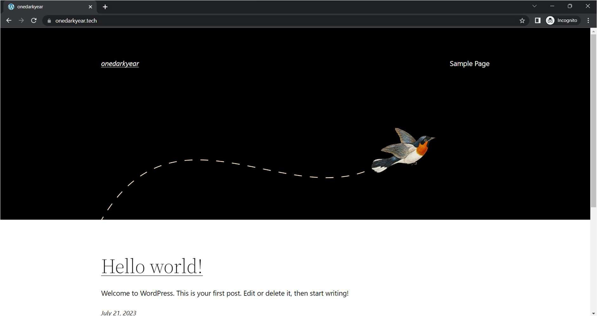

*Figure 1 UI of our deployed website "onedarkyear.tech"*

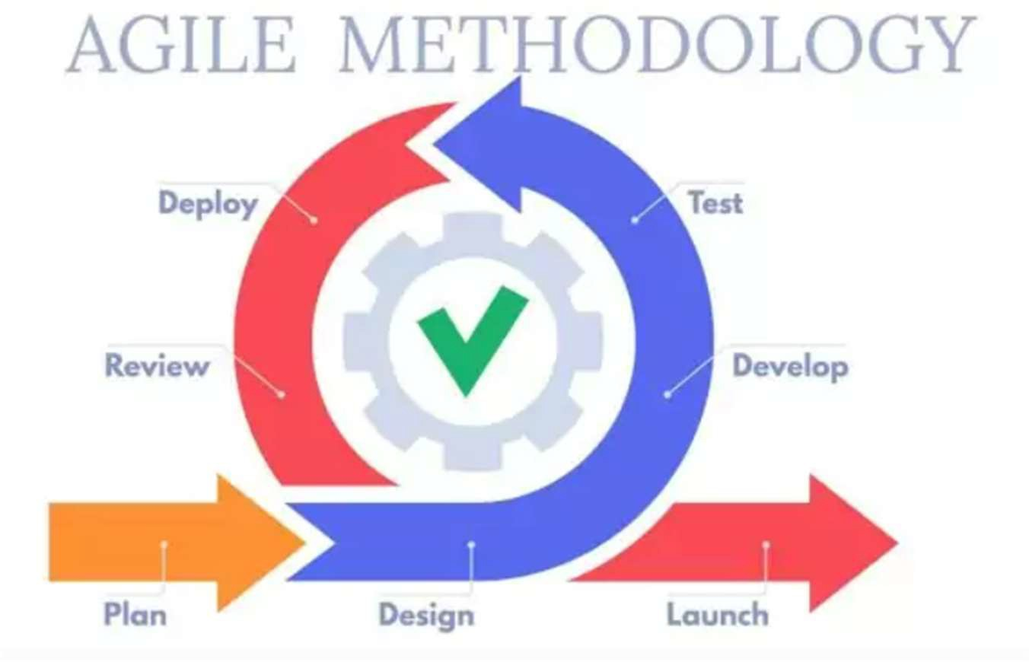

*Figure 2: Iterative approach of the Agile planning model*

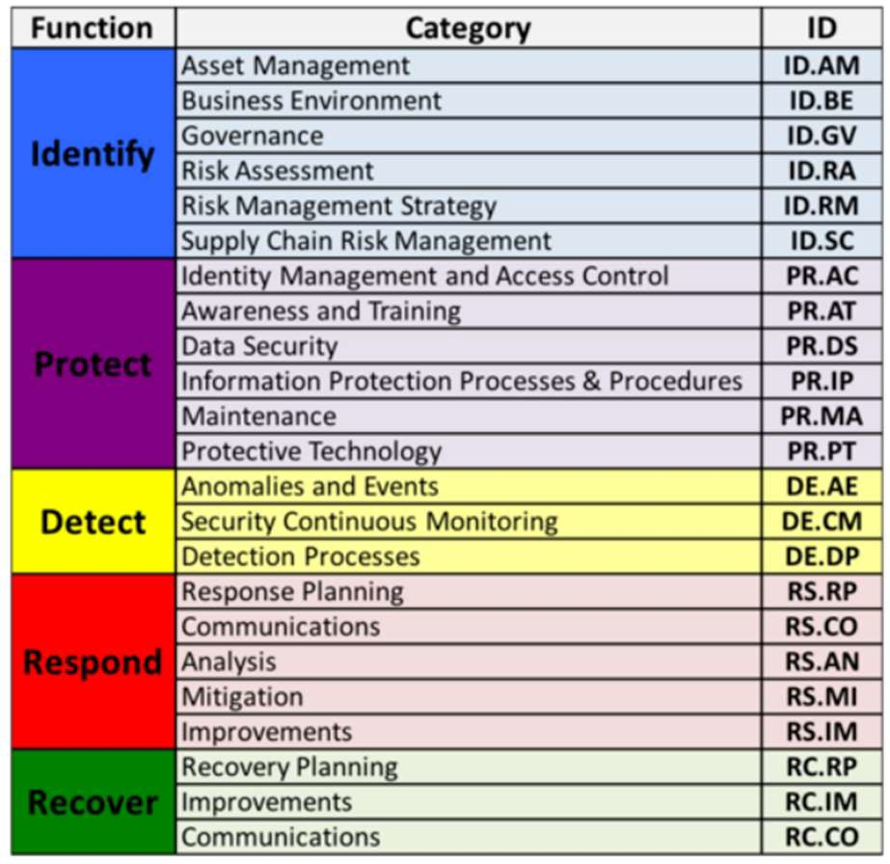

*Figure 3: core 5 functions of NIST*

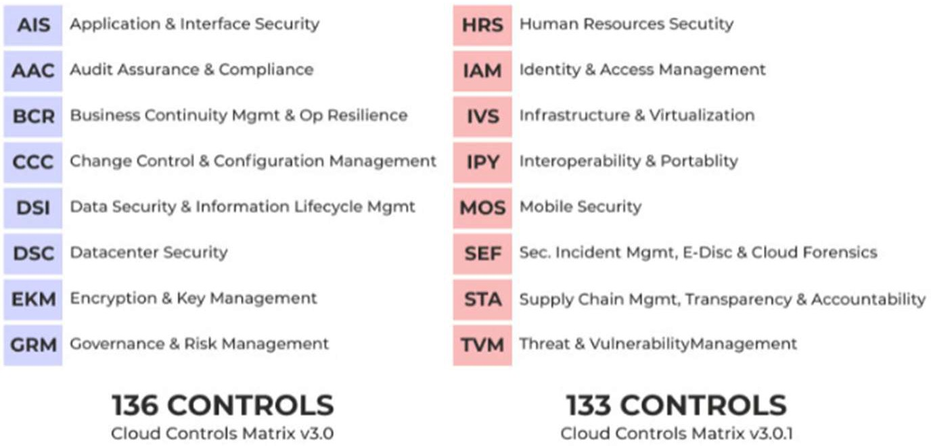

*Figure 4: Cloud Control Matrix*

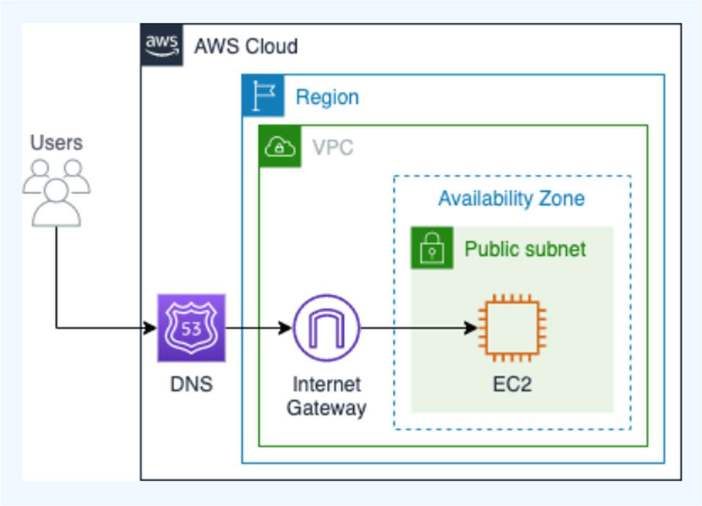

*Figure 5: Cloud Architecture Diagram*

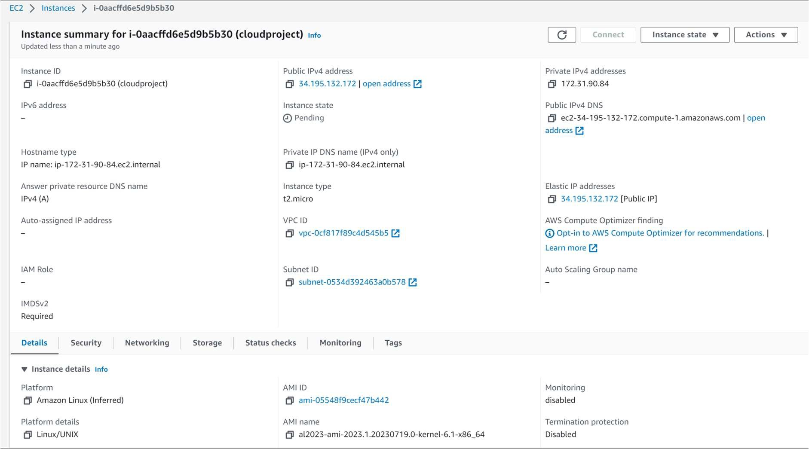

*Figure 6: Instance of our project*

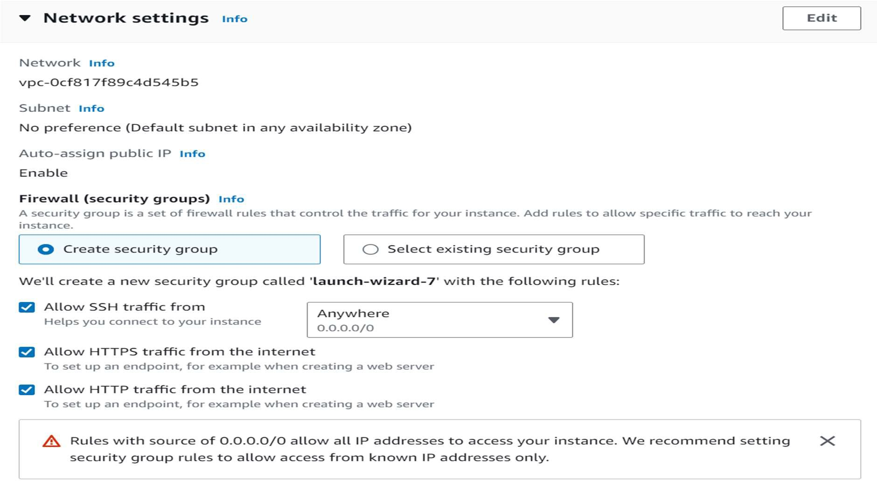

*Figure 7: Network settings of instance*



*Figure 8: Elastic Ip*

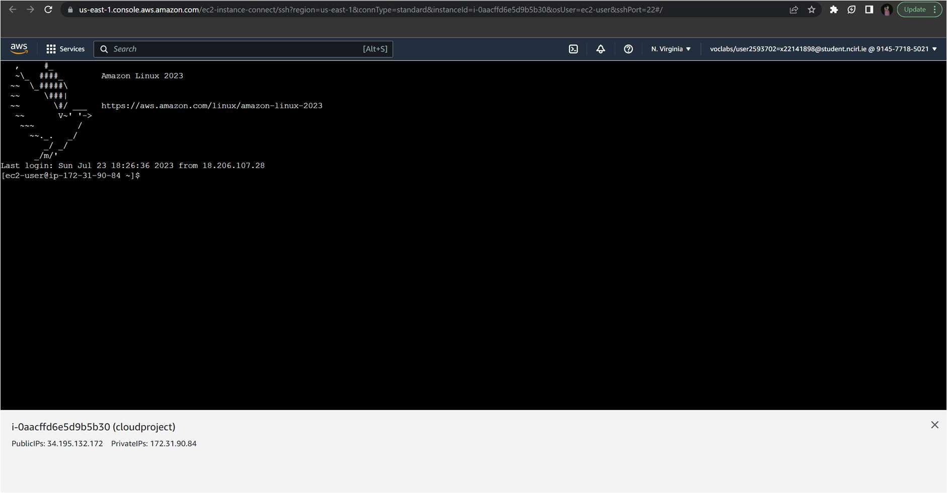

*Figure 9: SSH in browser*



*Figure 10: update all packages.*



*Figure 11: install latest versions of Apache web server and PHP packages.*



*Figure 12: Install MariaDB*

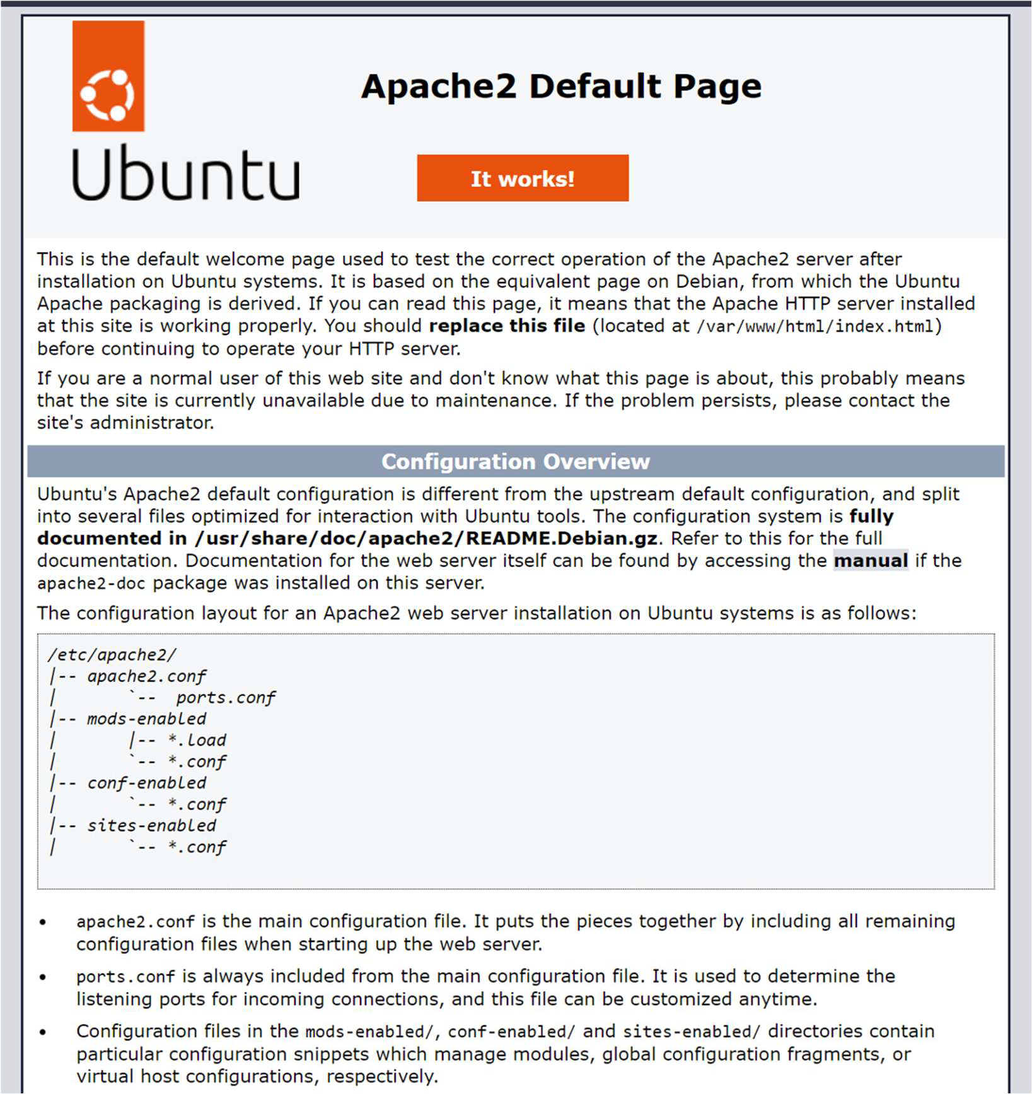

*Figure 13: Apache working*



*Figure 14: Give group ownership of the /var/www directory ec2-user.*



*Figure 15: PHP file in the Apache root directory.*

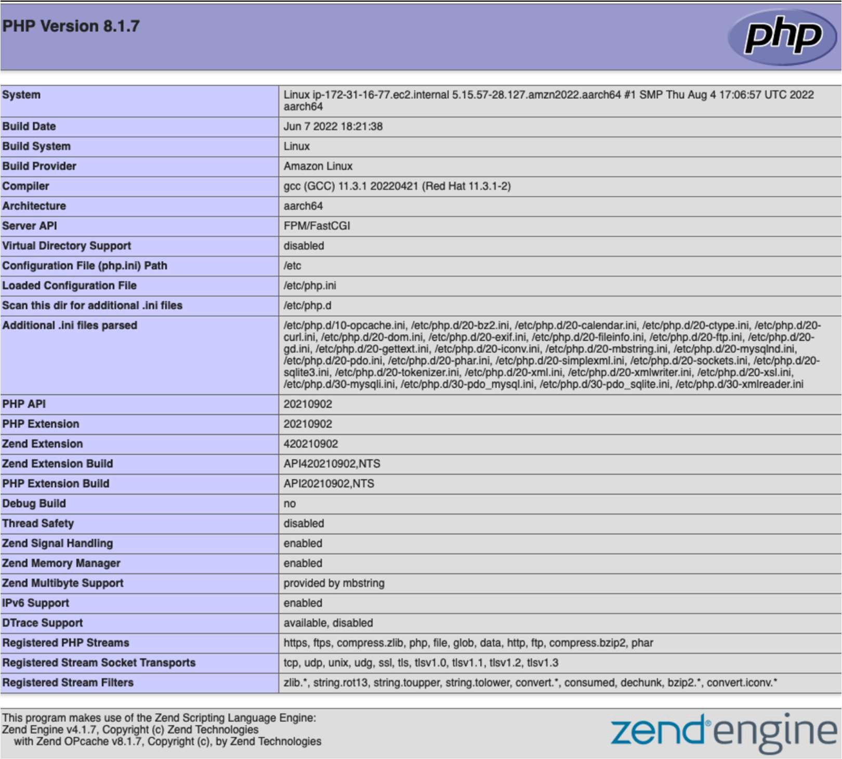

*Figure 16: verification of phpinfo.php file being created in /var/www/html/*

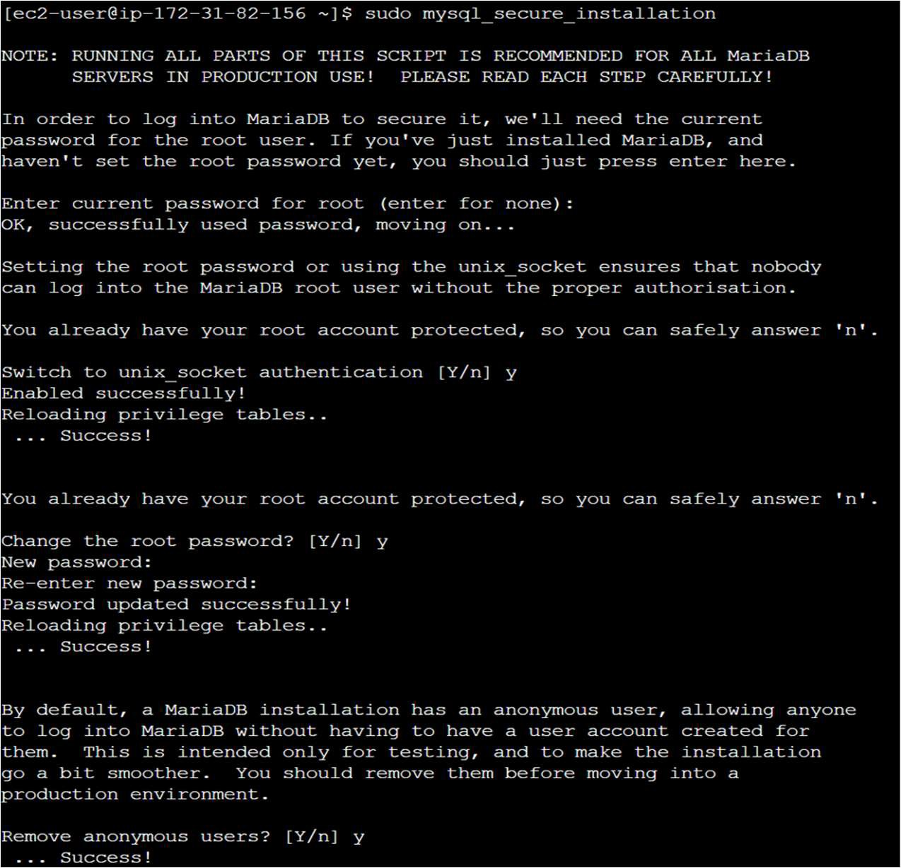

*Figure 17: Securing MariaDB*

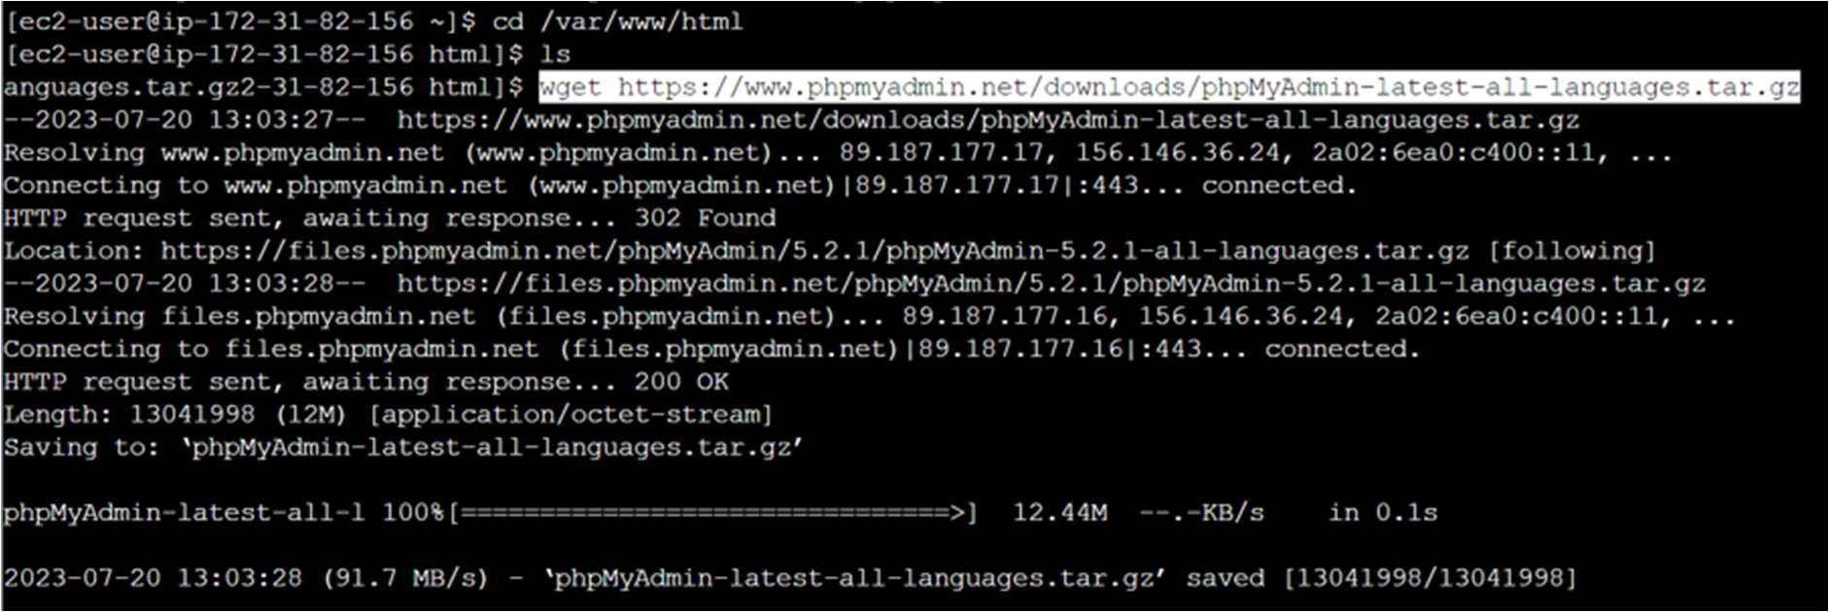

*Figure 18: Installing phpMyAdmin in /var/www/html.*



*Figure 19: deleting the rm phpMyAdmin file after installation.*

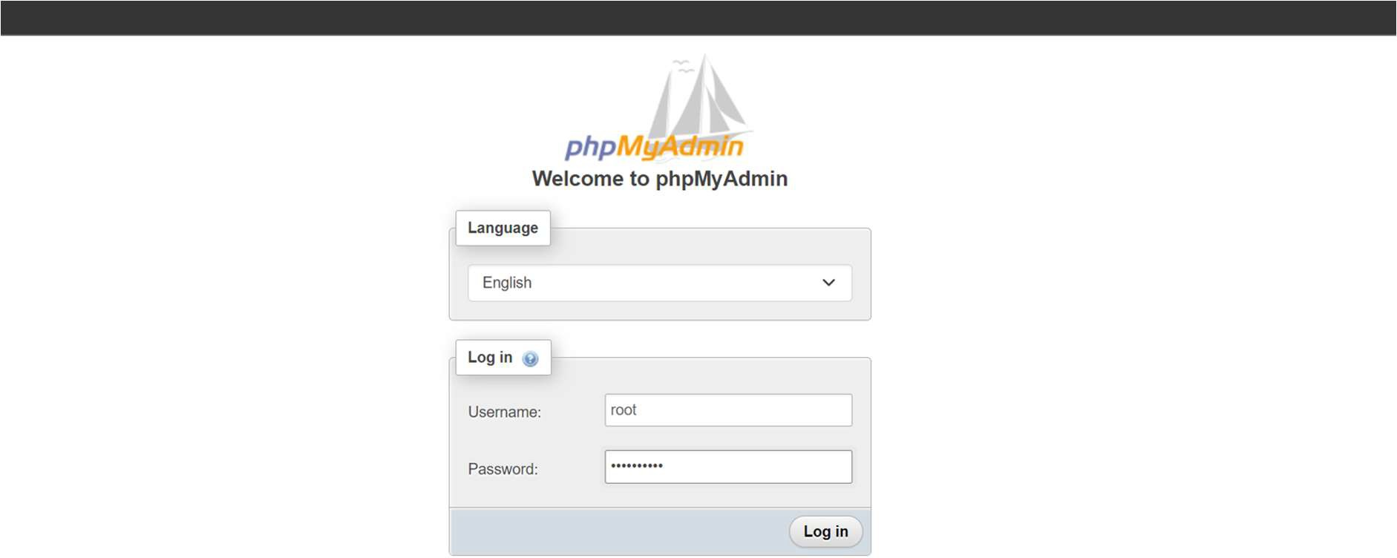

*Figure 20: phpMyAdmin is working.*

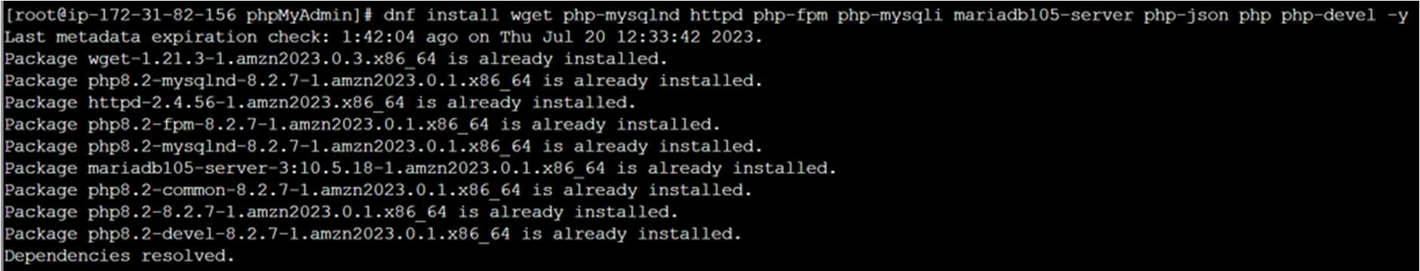

*Figure 21: Downloading required packages for WordPress*

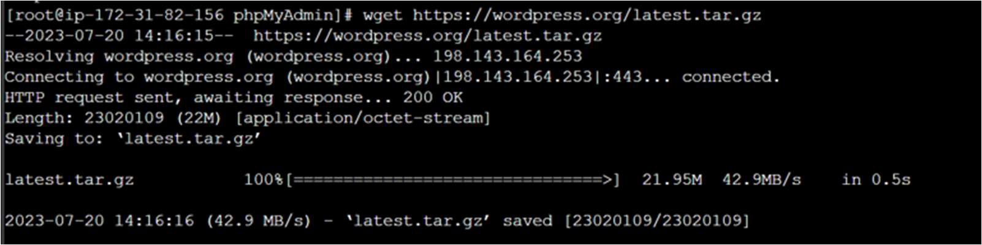

*Figure 22: Downloading and installing WordPress.*

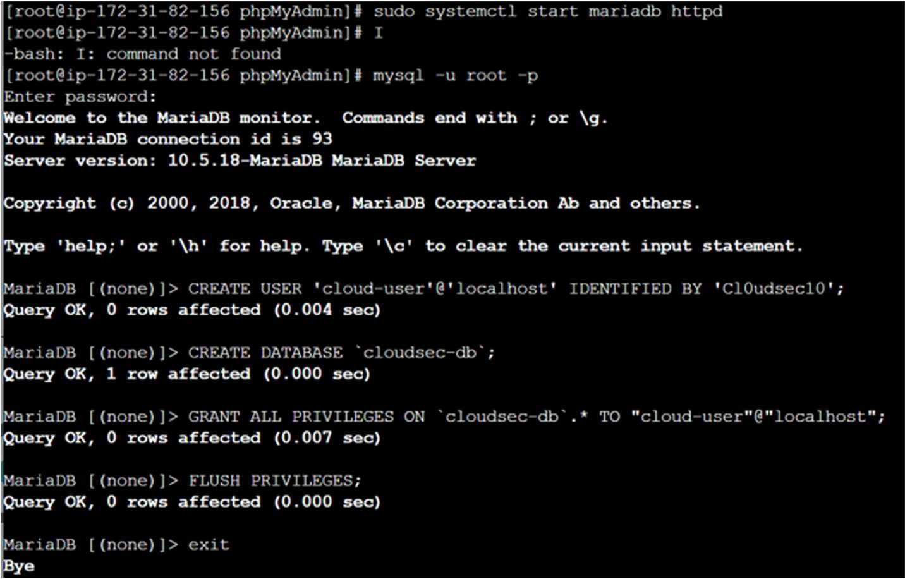

*Figure 23: Updating WordPress user details to database.*



*Figure 24: Copying and renaming wp-config-sample.php file to wp-config.php*



*Figure 25: Installing graphic libaries for wordpress.*



*Figure 26: Installation os Openssl*

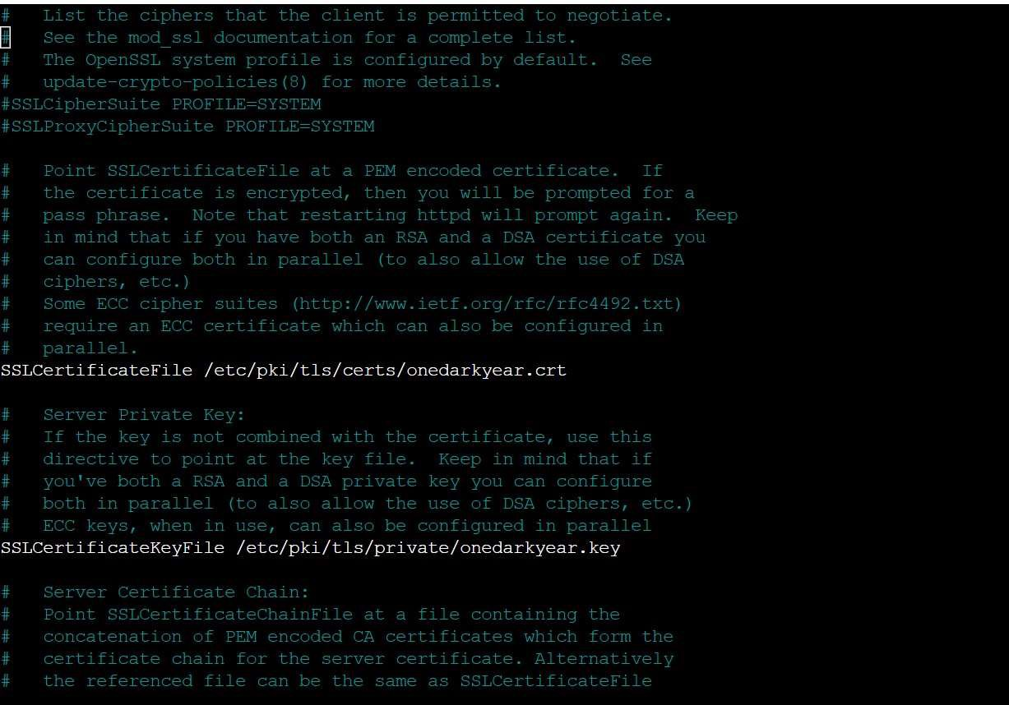

*Figure 27: Command to Create a seperate SSLcertificate file.*

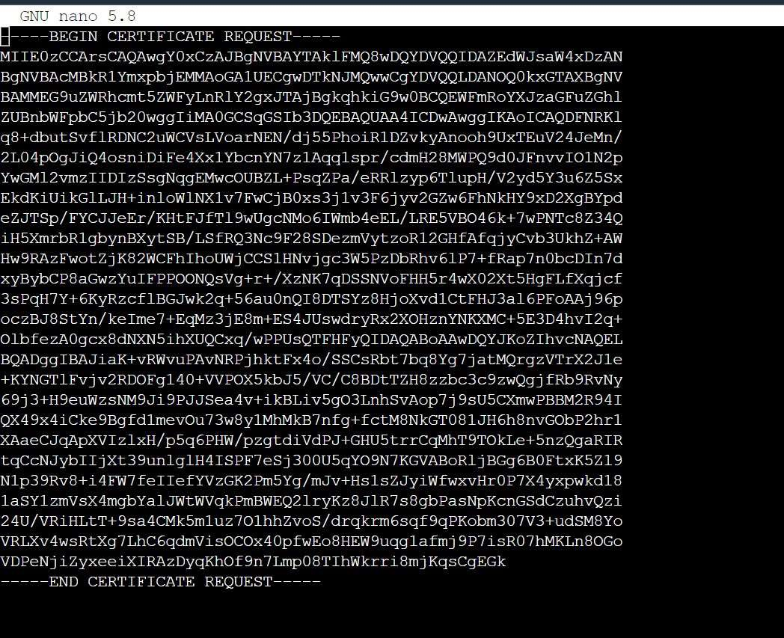

*Figure 28: Created open rsa file and openssl RSA private key file.*

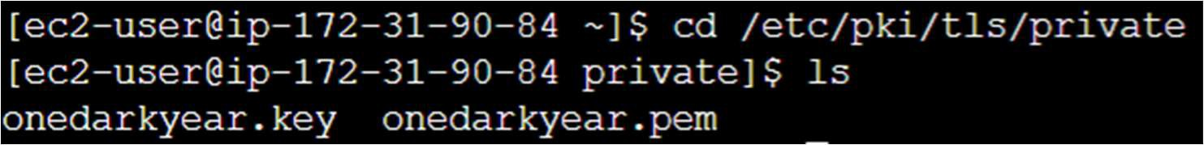

*Figure 29: go the /etc/pki/tls/private, find our private key*



*Figure 30: Generating a 4096-bit RSA private key*



*Figure 31: create a CSR using the key*



*Figure 32: initiating the registeration*

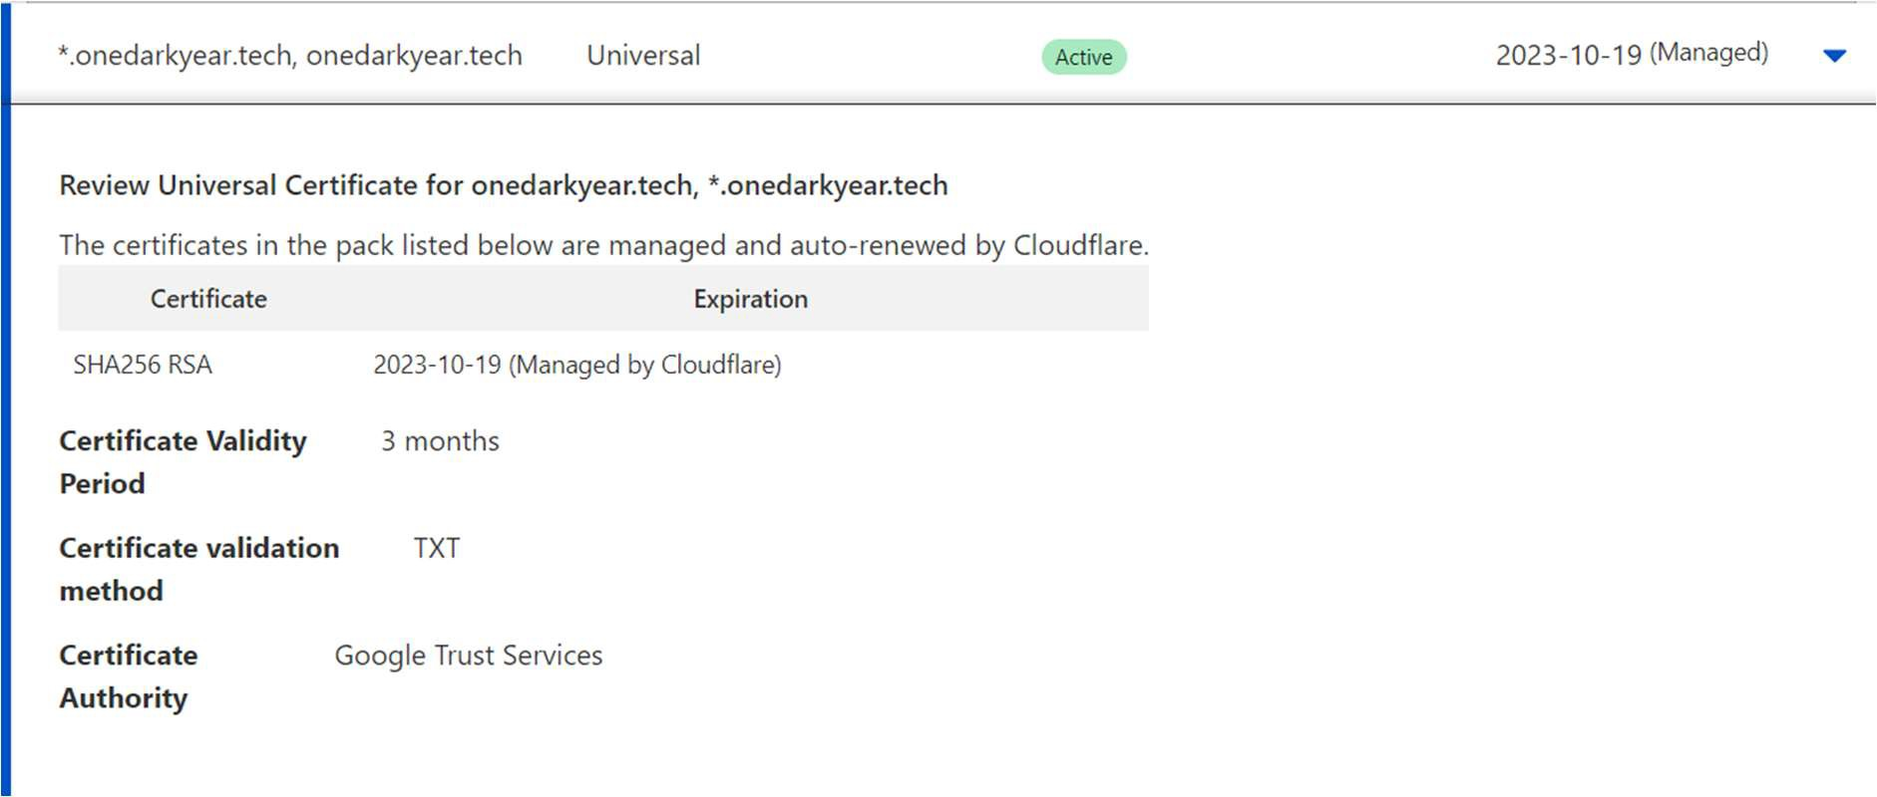

*Figure 33: configure Cloudflare to get CA -Signed certificate*



*Figure 34: open the cert.pem file*

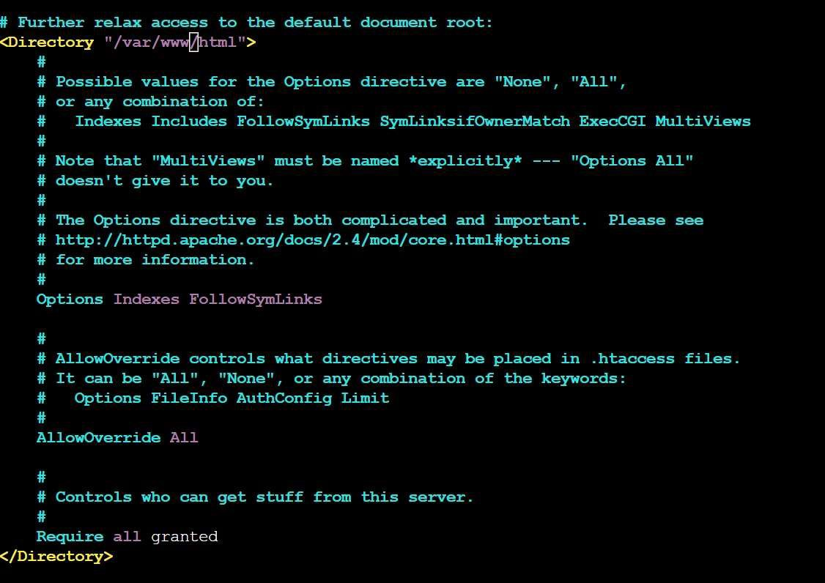

*Figure 35: Further relaxation of /var/www/html AllowOverride All*

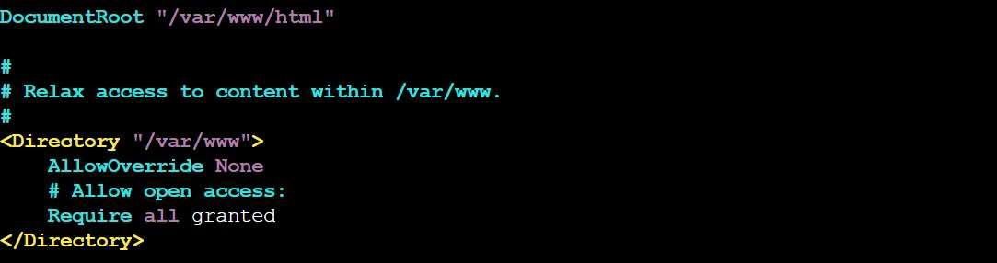

*Figure 36: /var/www AllOverride none*

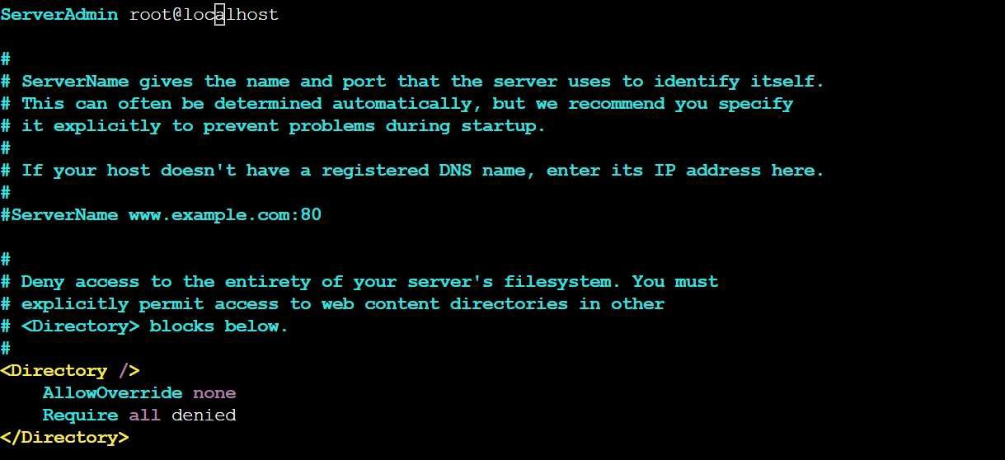

*Figure 37: root@local host AllowOverride none and Require all denied*

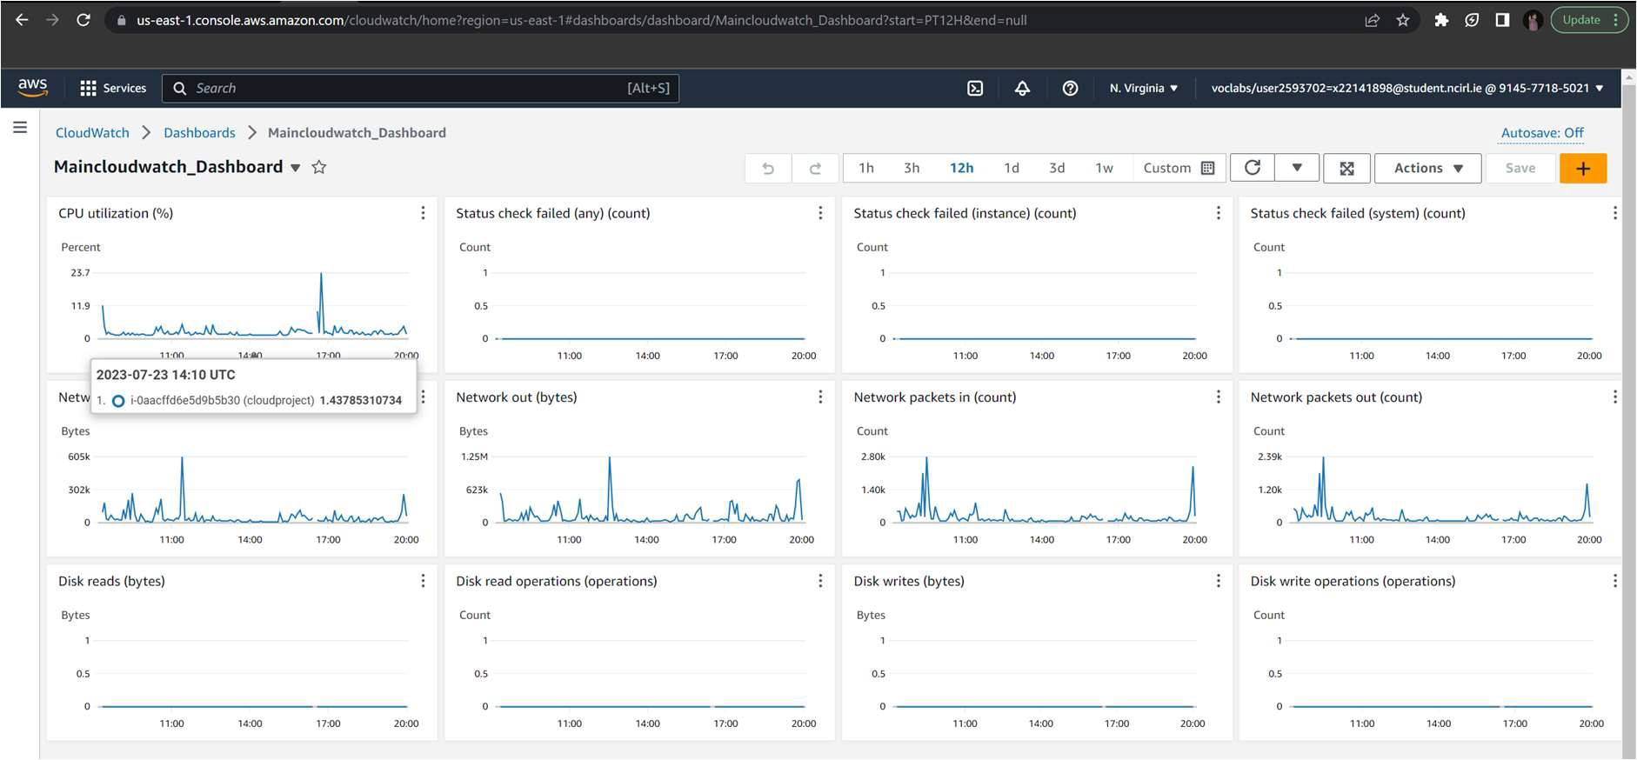

*Figure 38: CloudWatch*

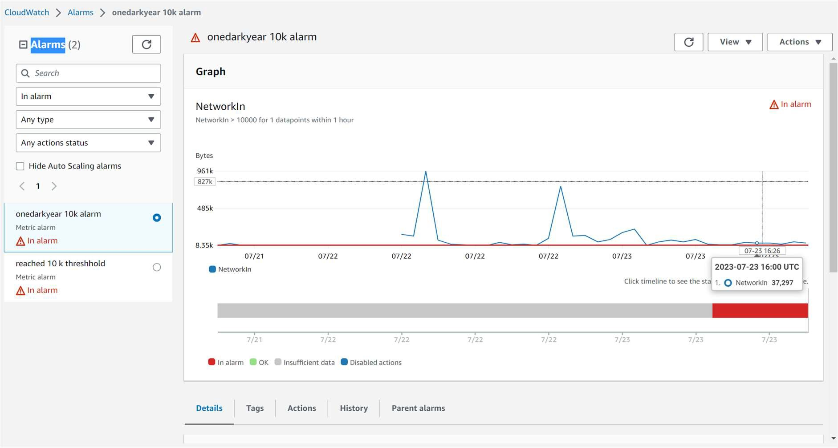

*Figure 39: CloudWatch demonstrating alarm*

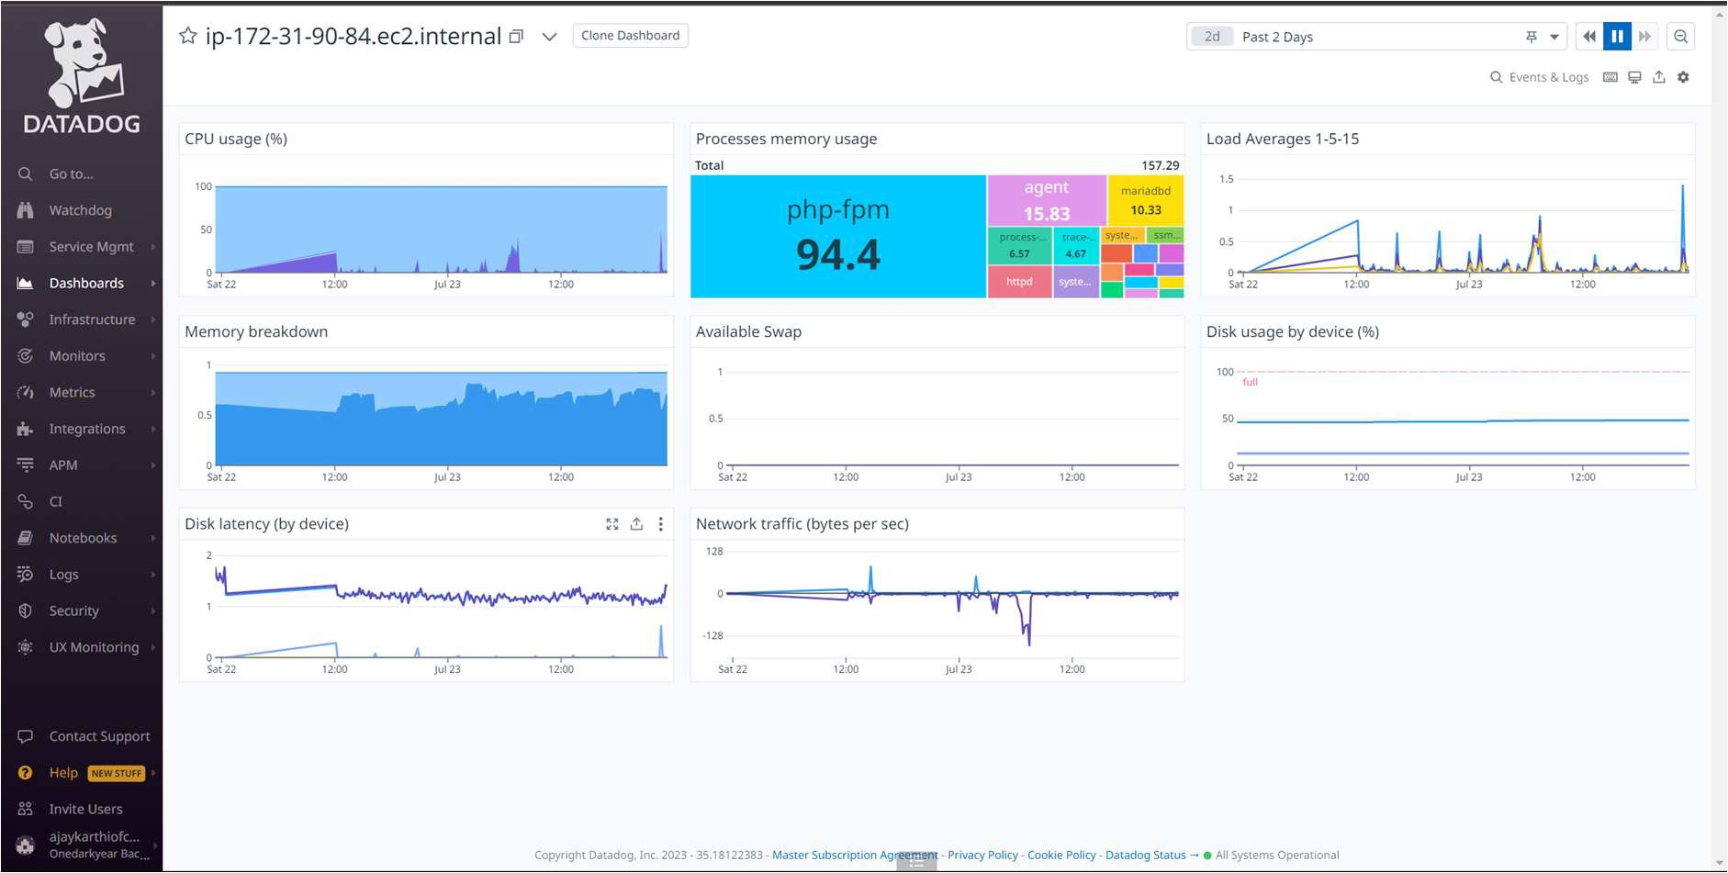

*Figure 40: DataDog*

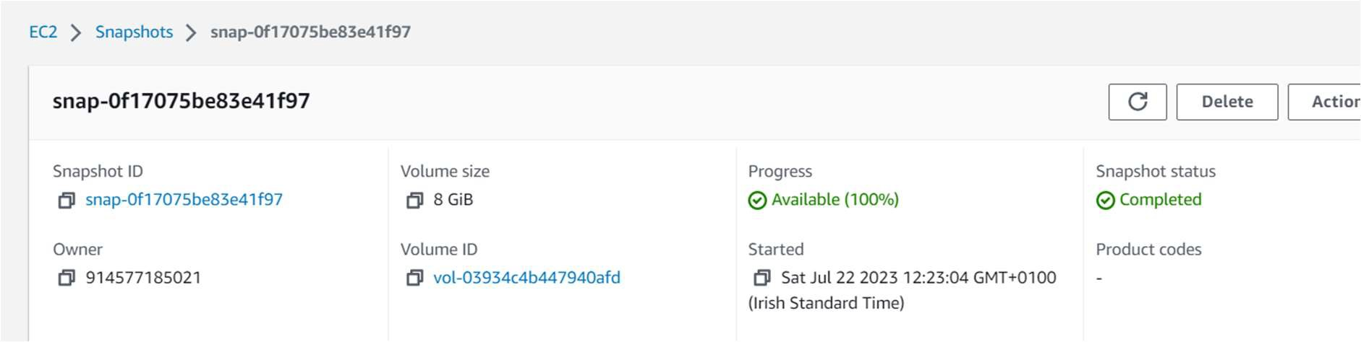

*Figure 41: Snapshot*

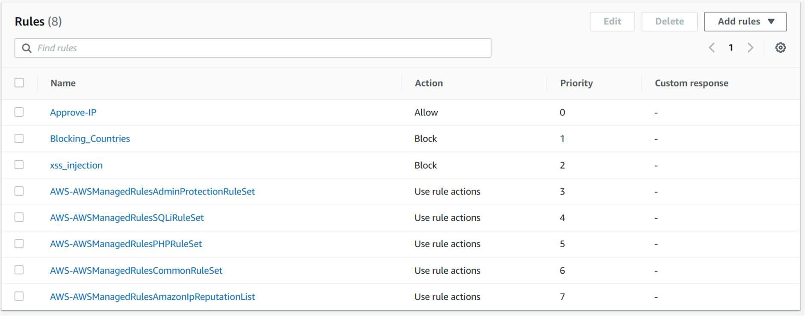

*Figure 42: AWS WAF Rules*

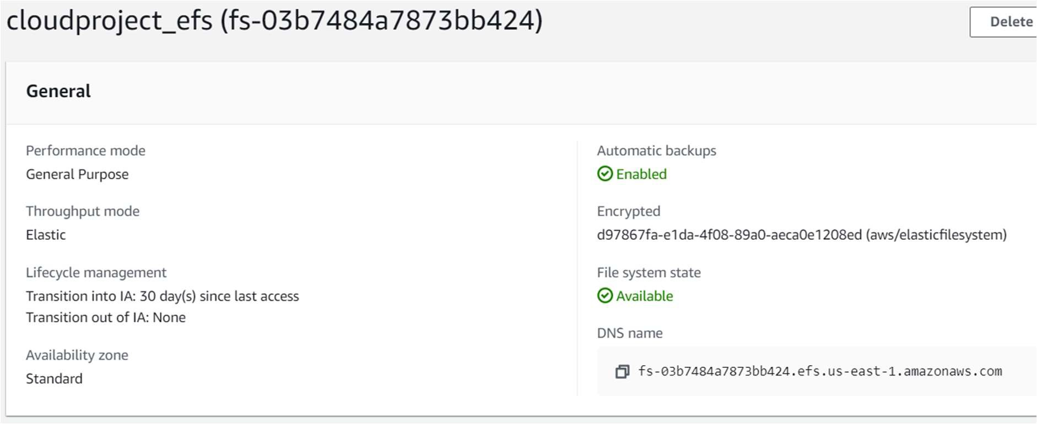

*Figure 43: EFS*

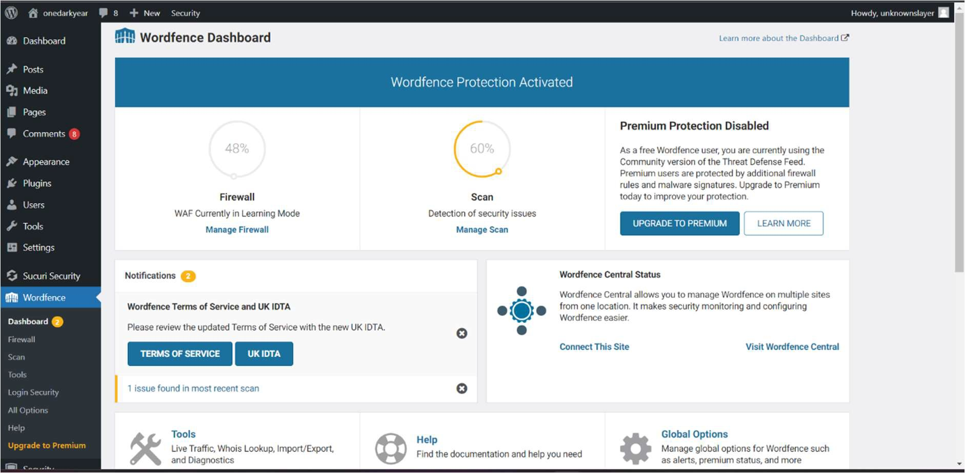

*Figure 44: enable two factor authentication in Wordfence.*

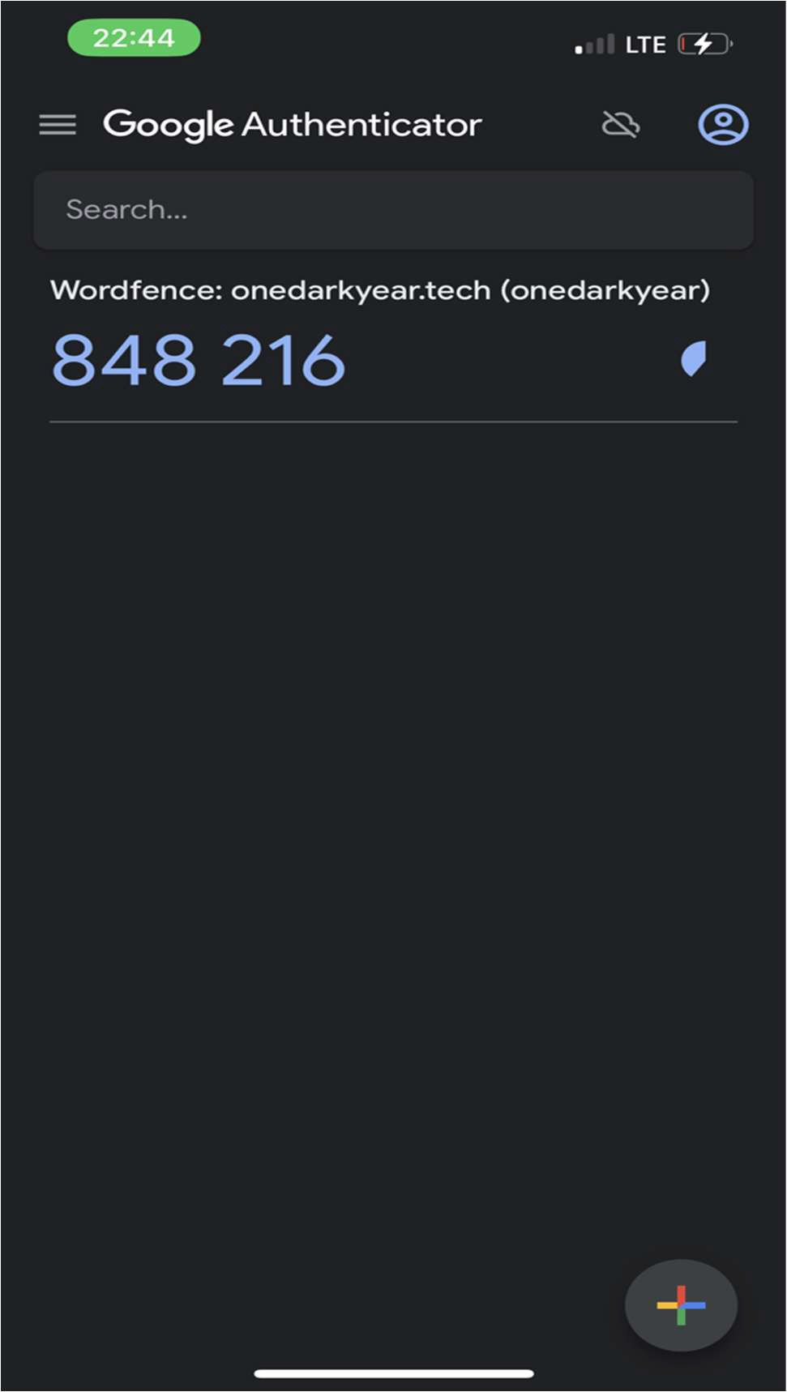

*Figure 45: Authentication code for 2FA using google authenticator.*

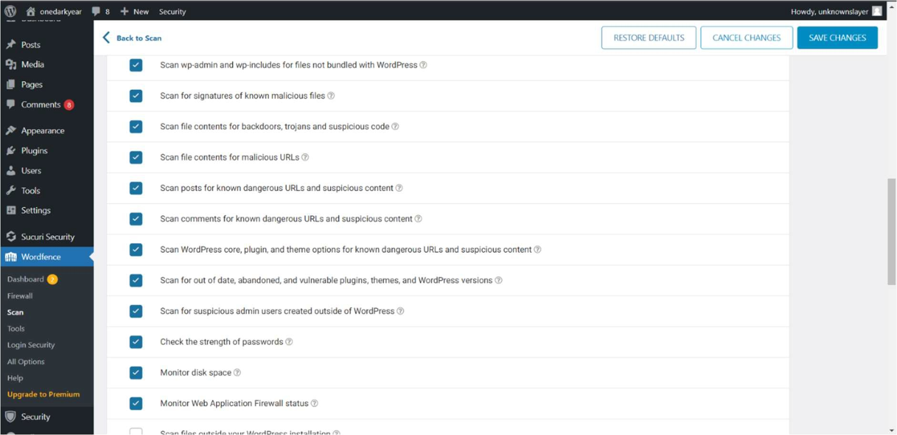

*Figure 46: Other features included in wordfence*

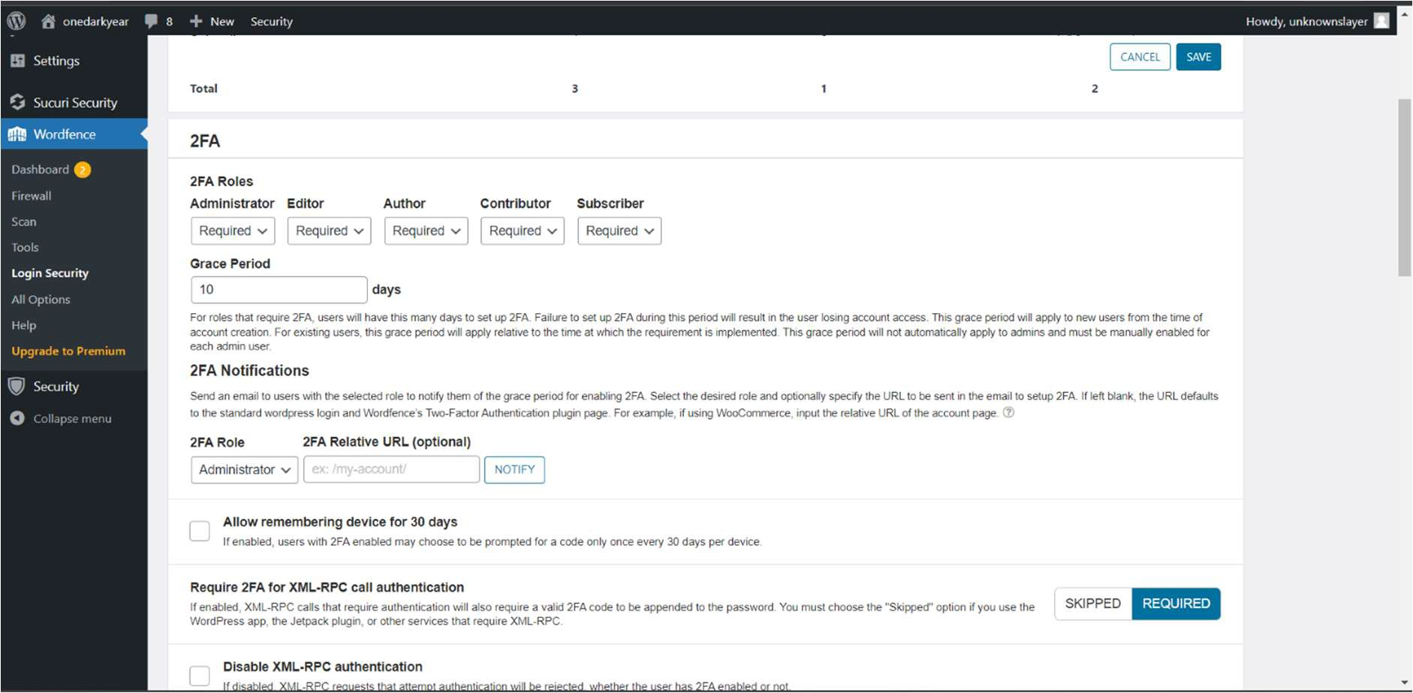

*Figure 47: Grace period of 10days to activate 2FA*

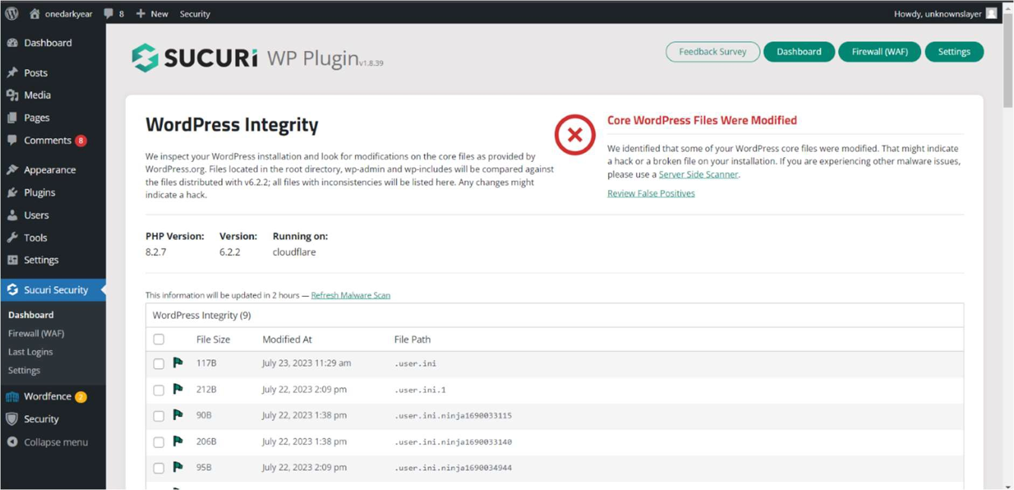

*Figure 48: Sucuri file integrity check*

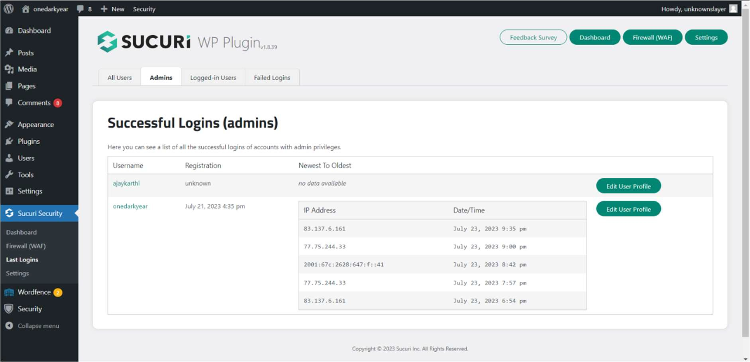

*Figure 49: successful admins login record*

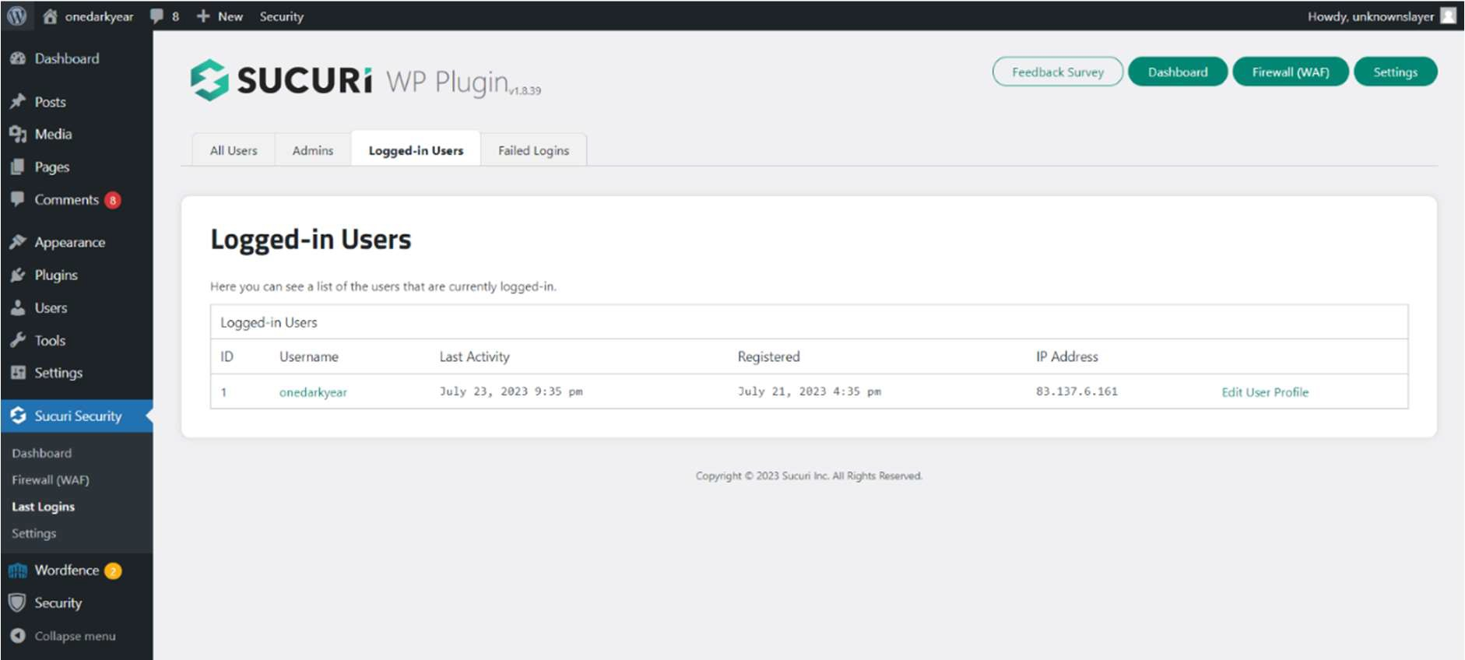

*Figure 50: record showing current Logged-in users*

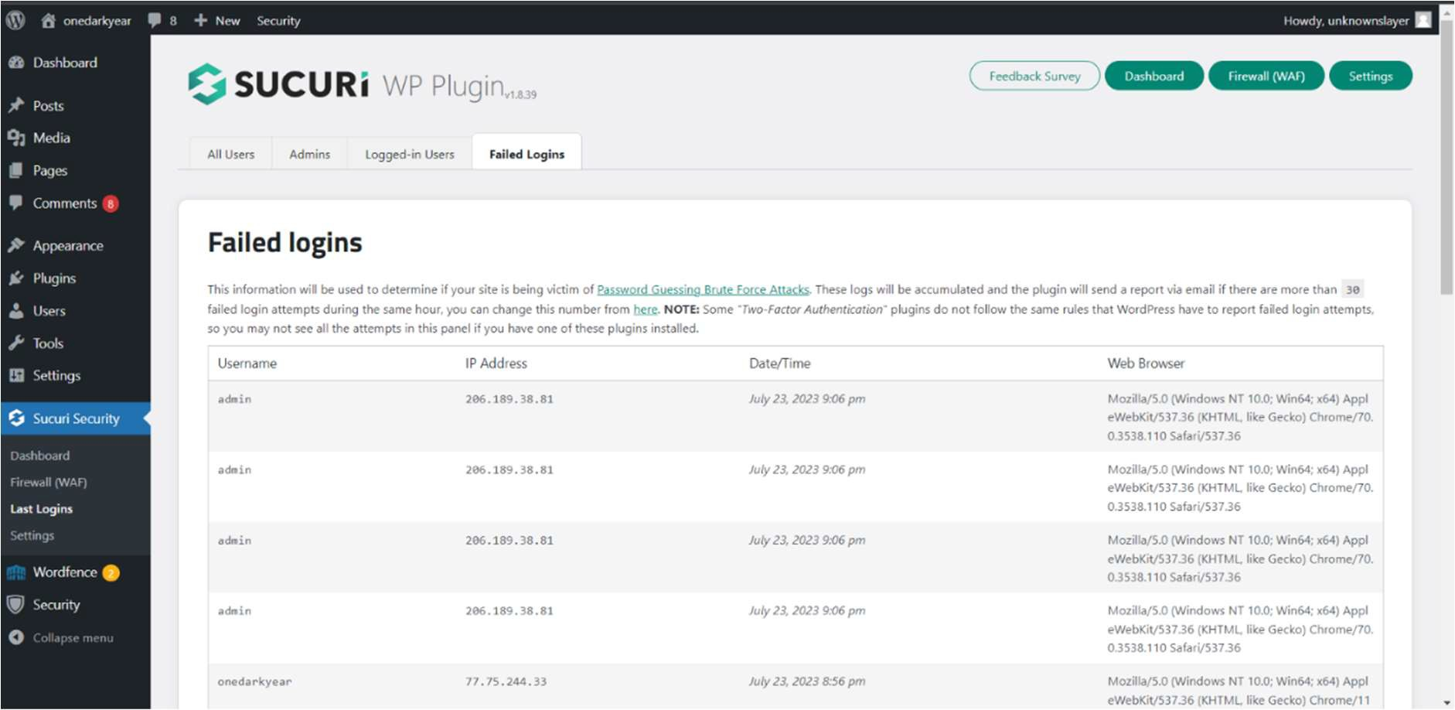

*Figure 51: record showing failed login attempts.*

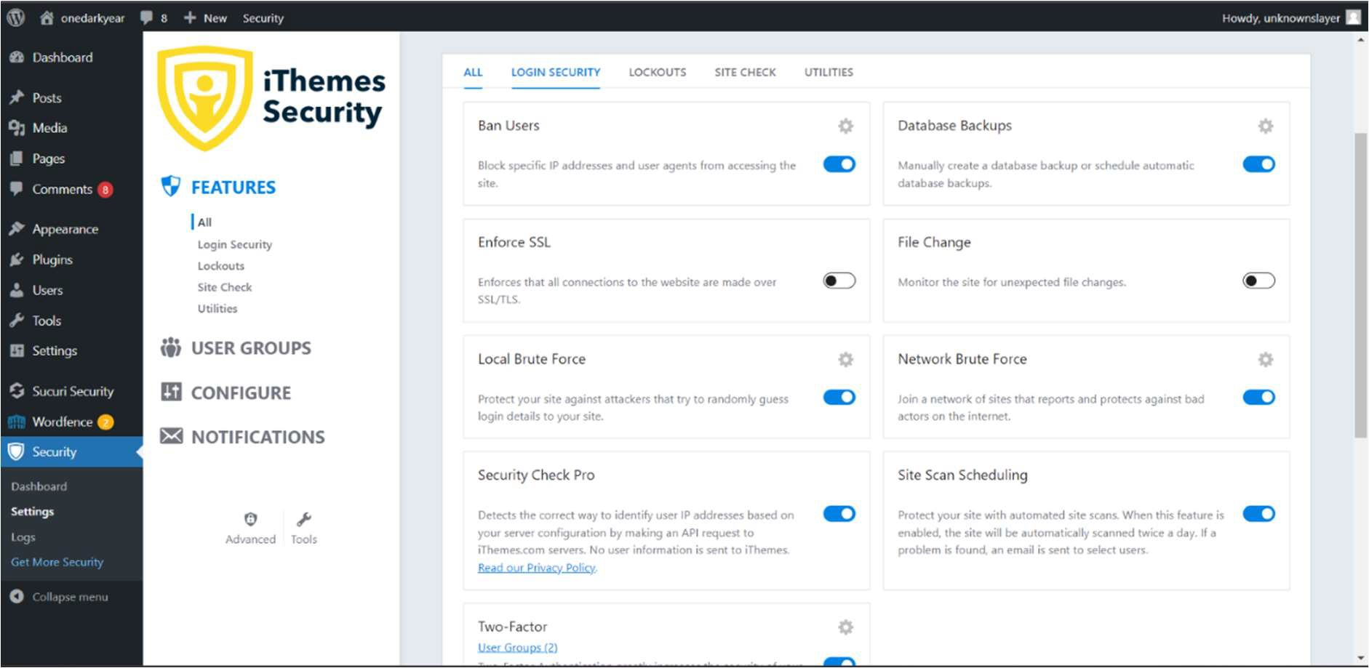

*Figure 52: IThemes security anti brute force capabilities.*

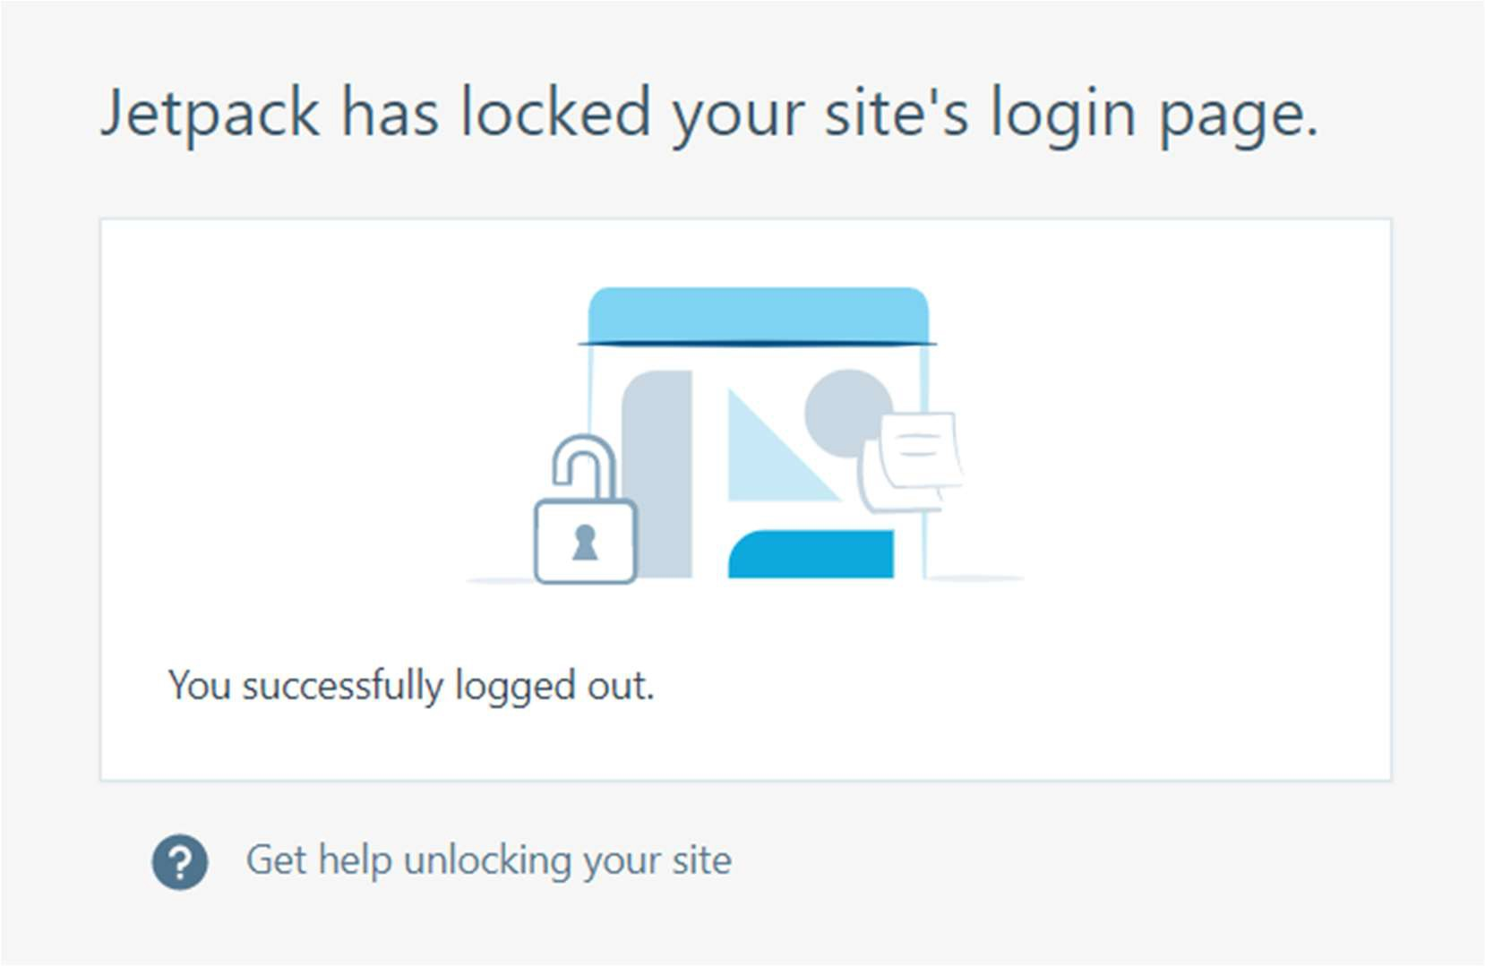

*Figure 53: Jetpack auto logout feature.*

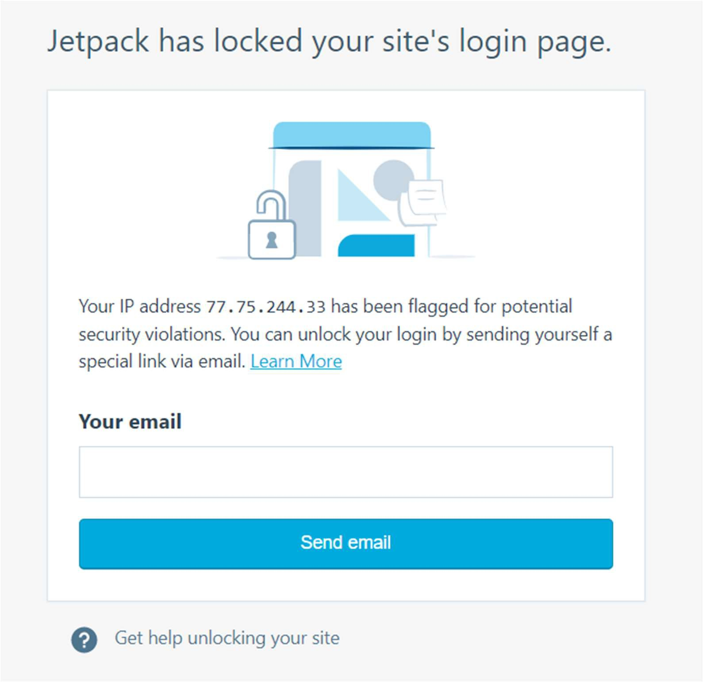

*Figure 54: jetpack plugin capability to block user after n number of login attemps.*

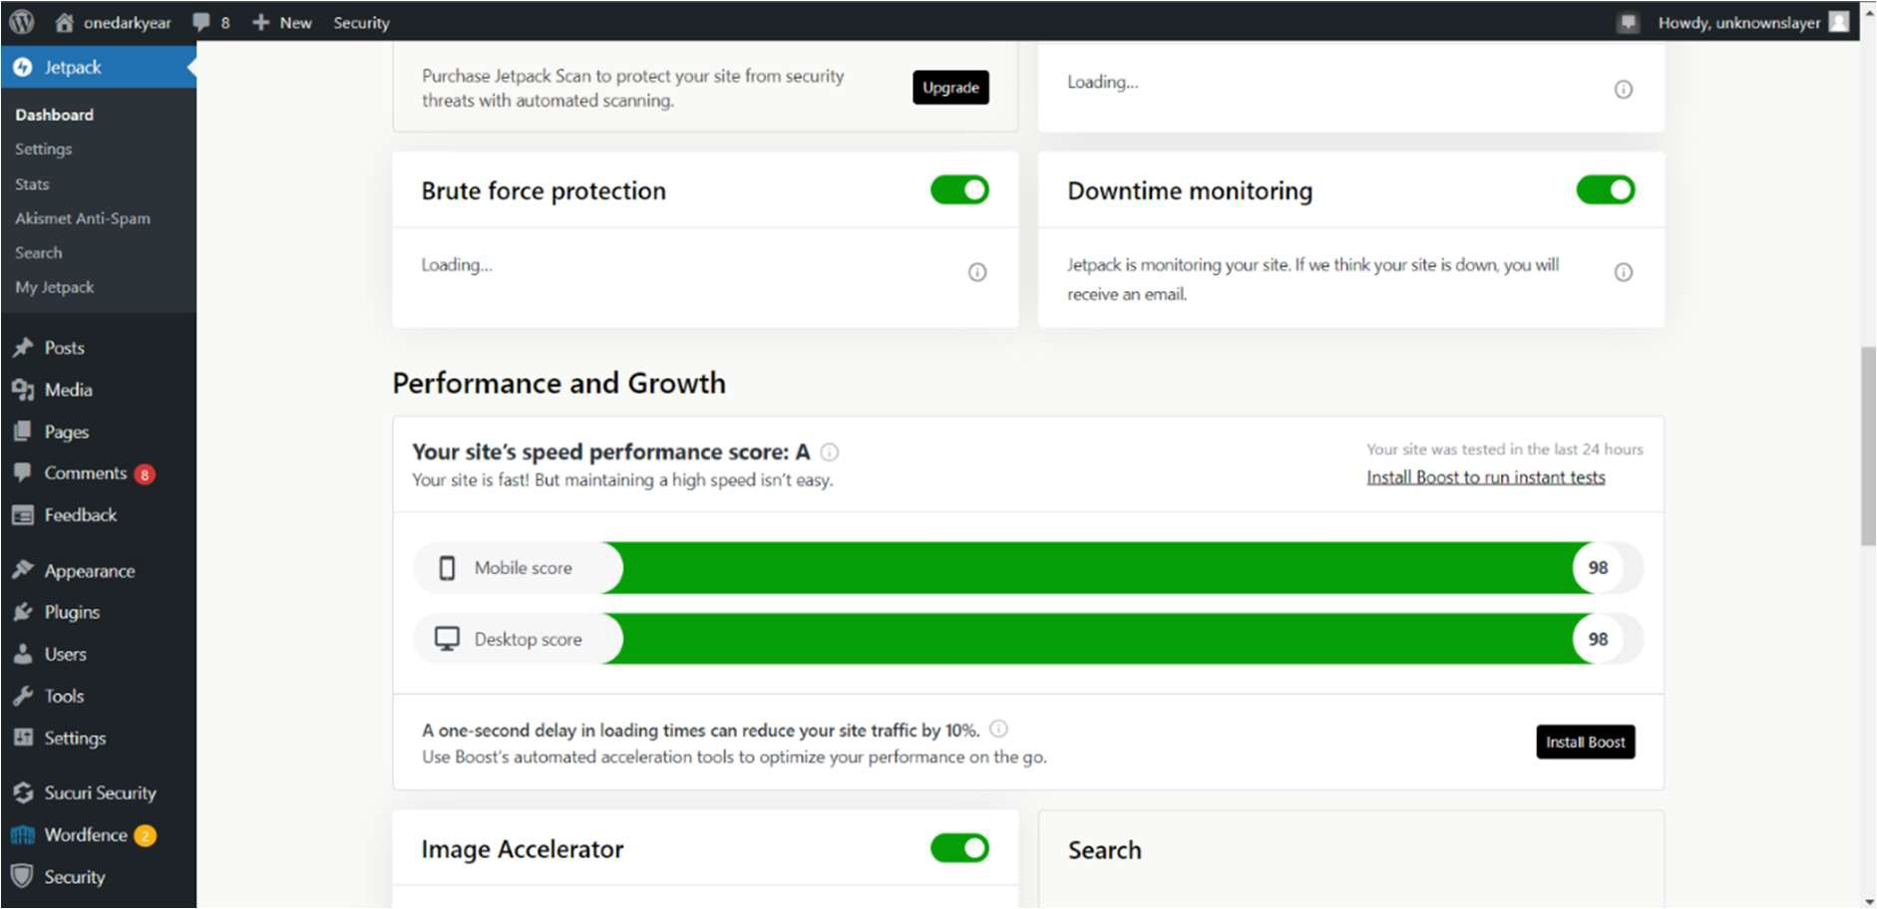

*Figure 55: Jetpack even performance calculator*

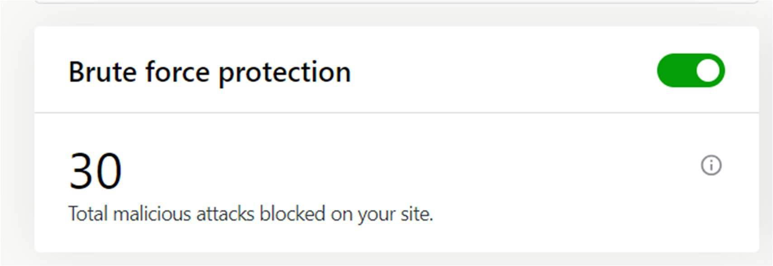

*Figure 56: test result against brute force attacks*

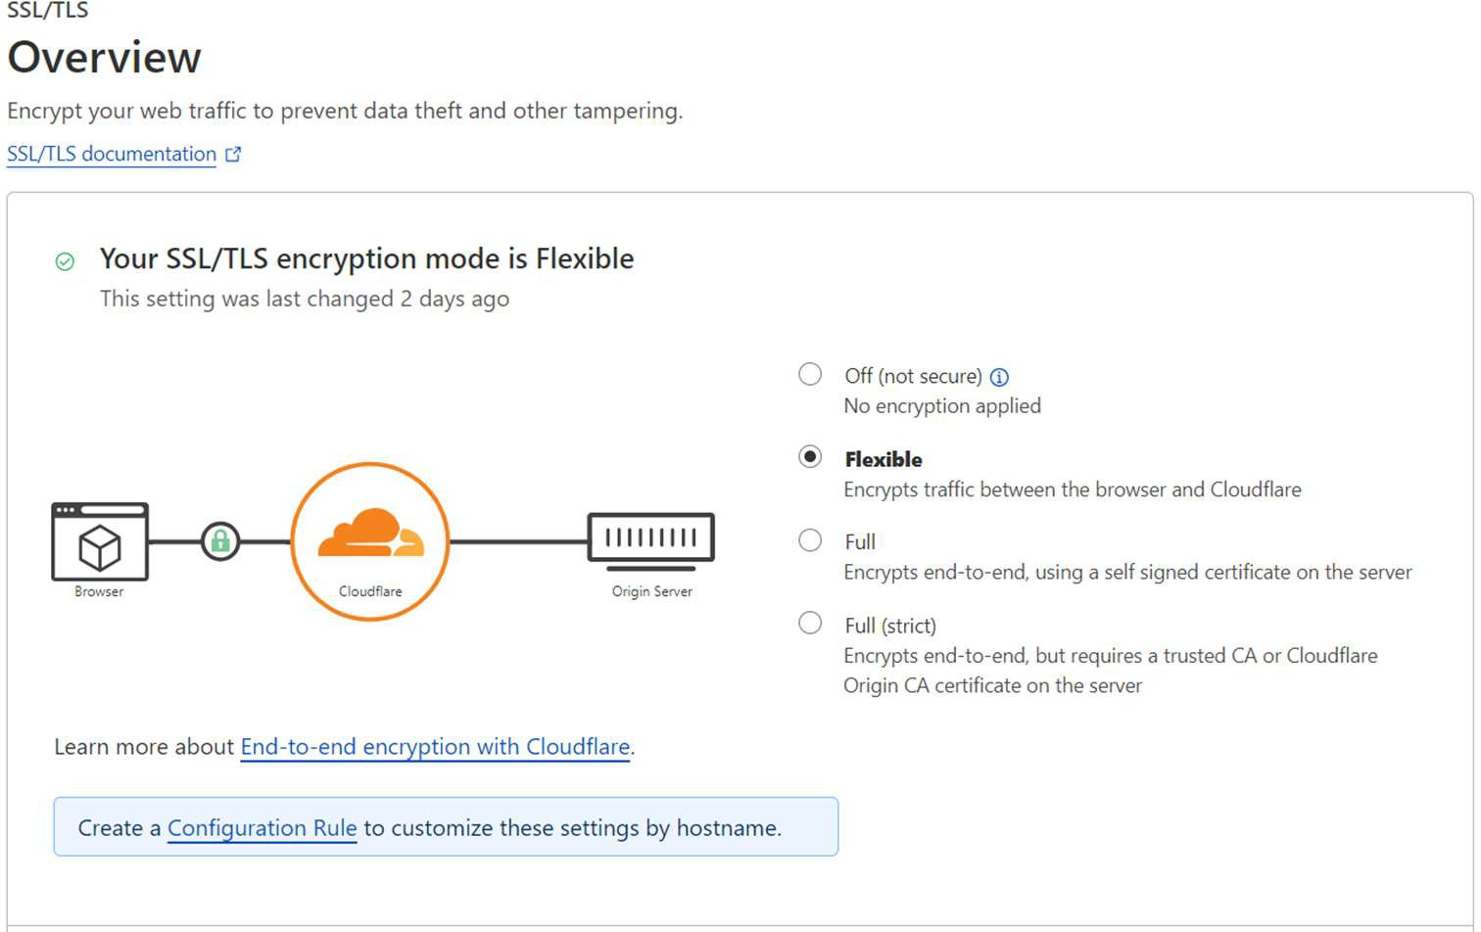

*Figure 57: Cloudflare setup.*

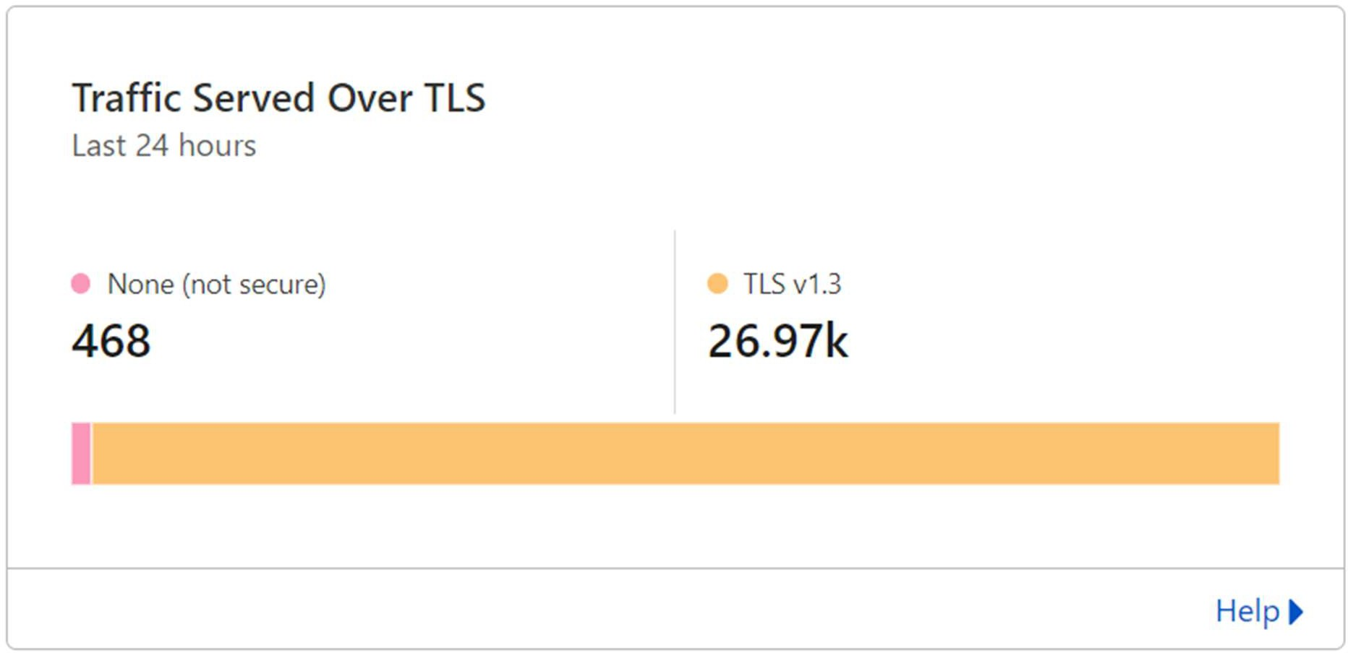

*Figure 58: Statisticsof requests converted to TLS v1.3*

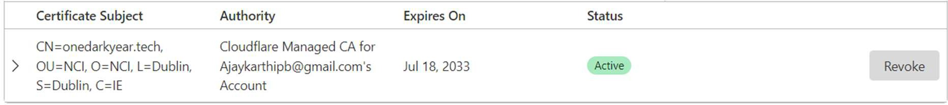

*Figure 59: Details of TSL certificate; subject, the authority and expiry date*

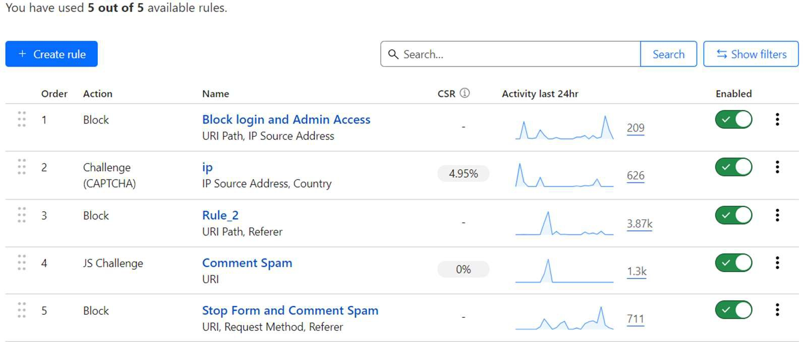

*Figure 60: rules to configer cloudflare*

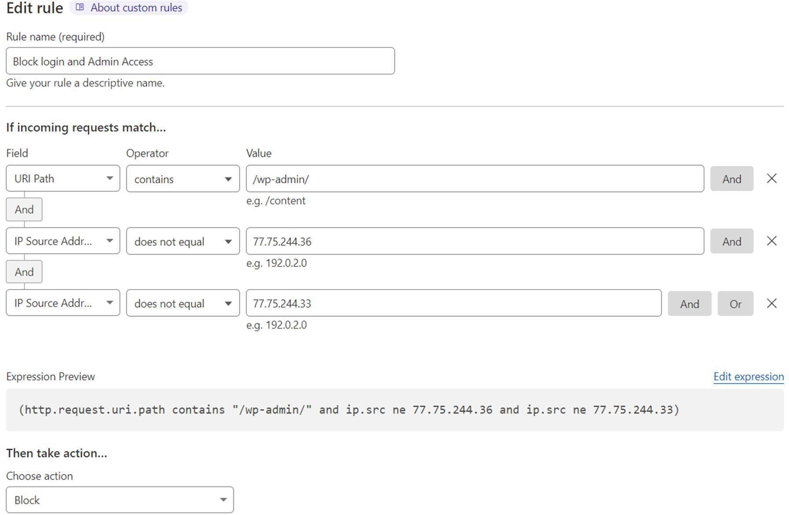

*Figure 61: Rule 1 in cloudflare.*

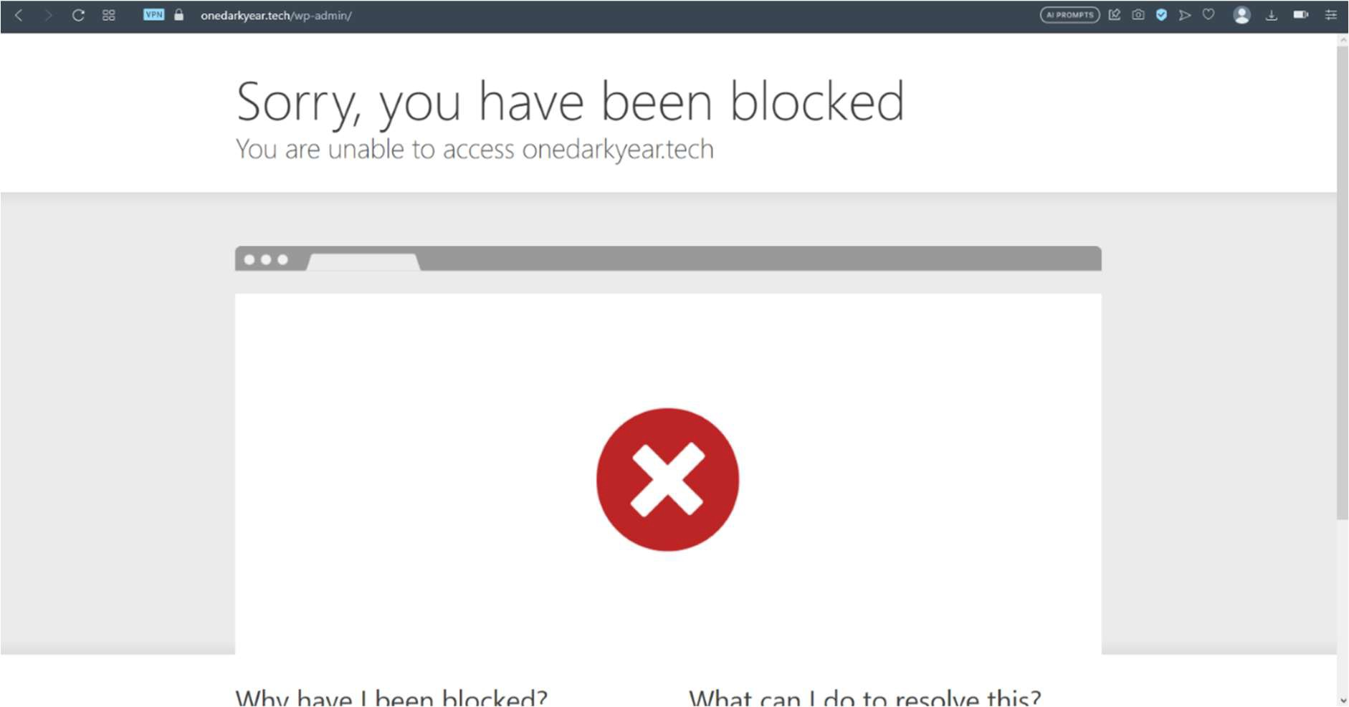

*Figure 62: result of rule 1.*

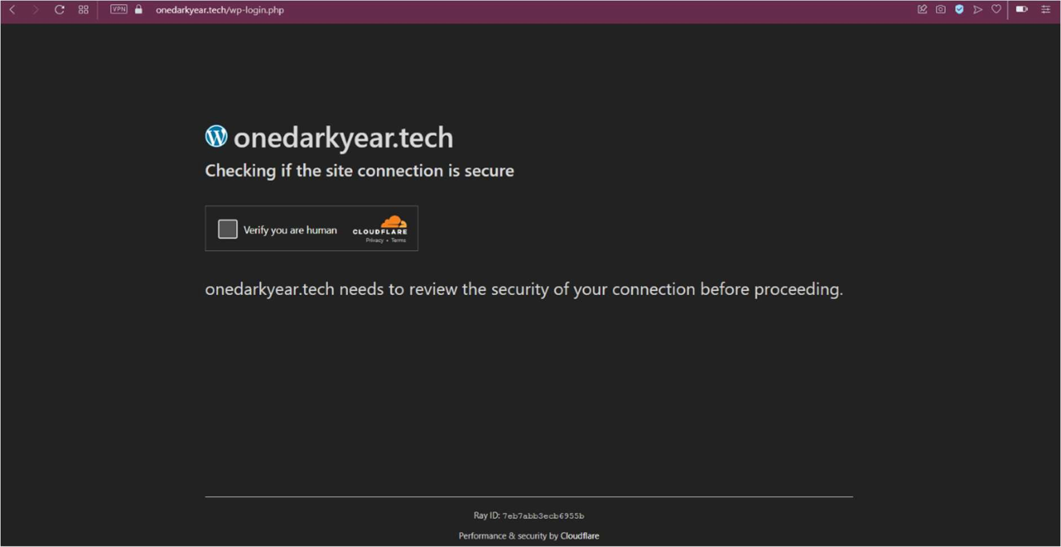

*Figure 63: Result of rule 2*

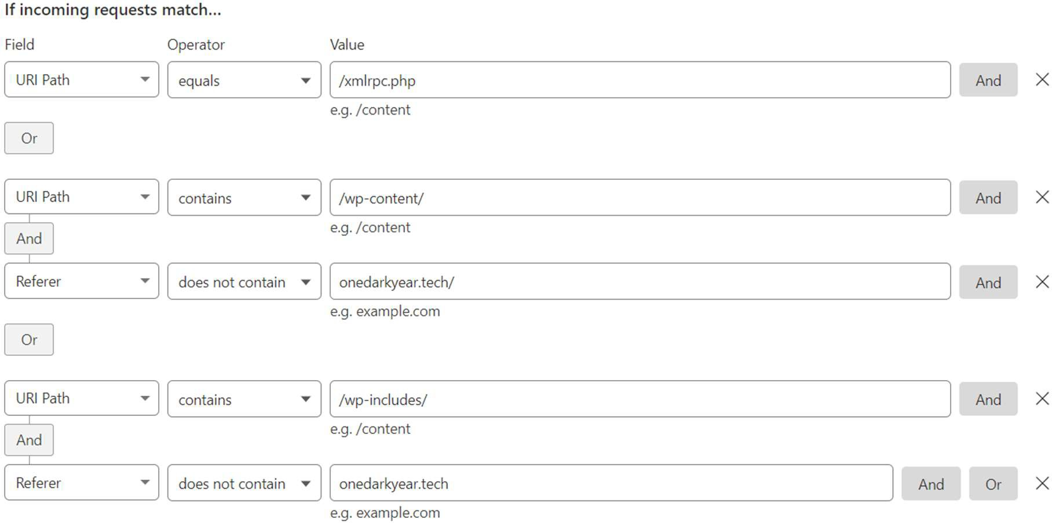

*Figure 64: Rule 3 in Cloudflare: access control.*

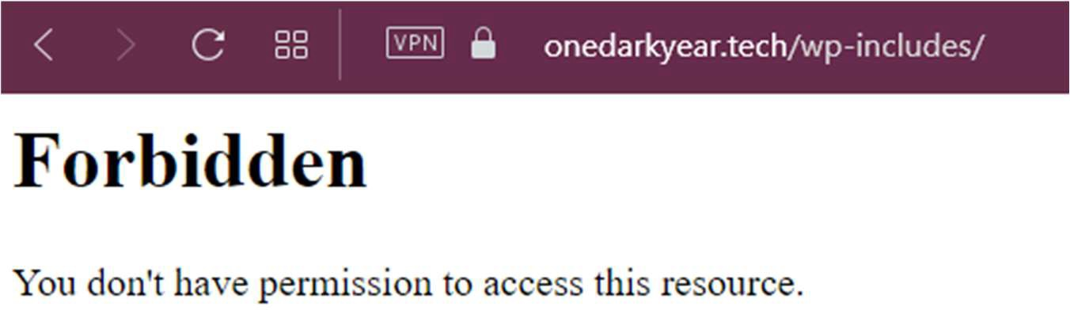

*Figure 65: Result of rule 3.*

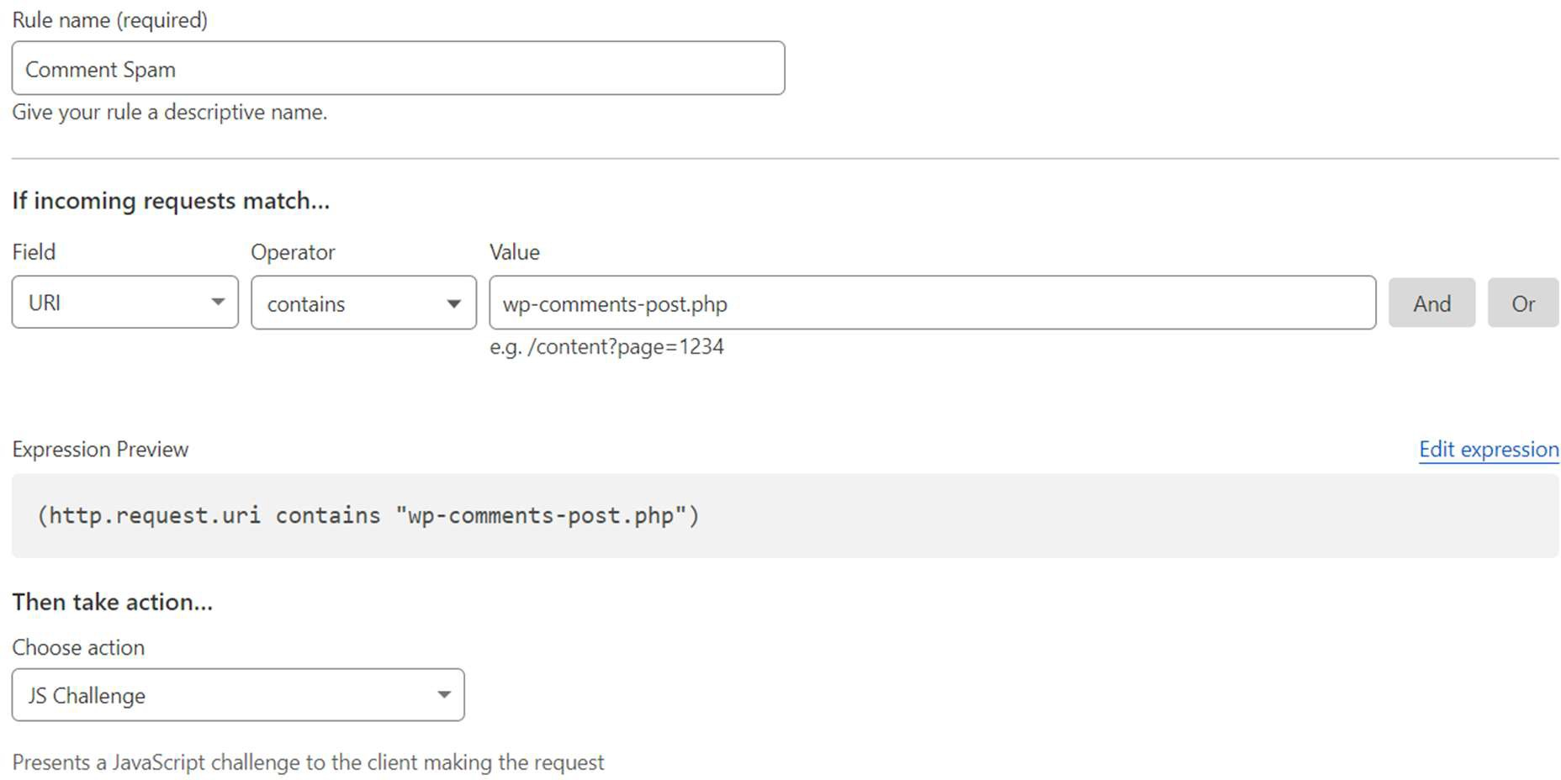

*Figure 66: Rule 4 in cloudflare: spam protection*

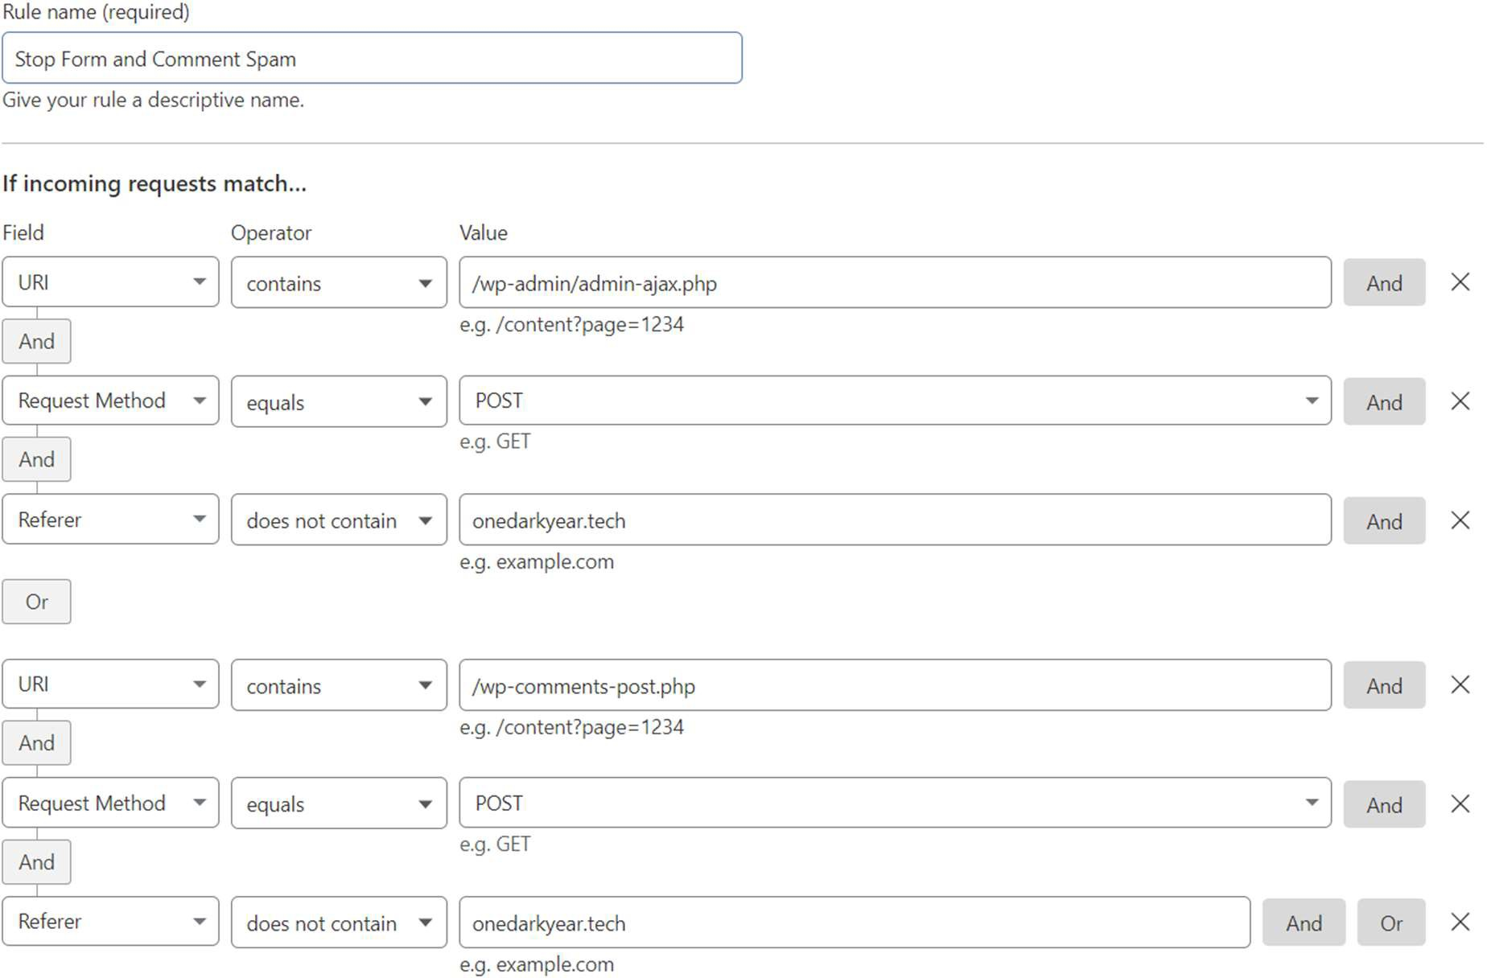

*Figure 67: Rule 5 in cloudflare: to stop form and comment spam*

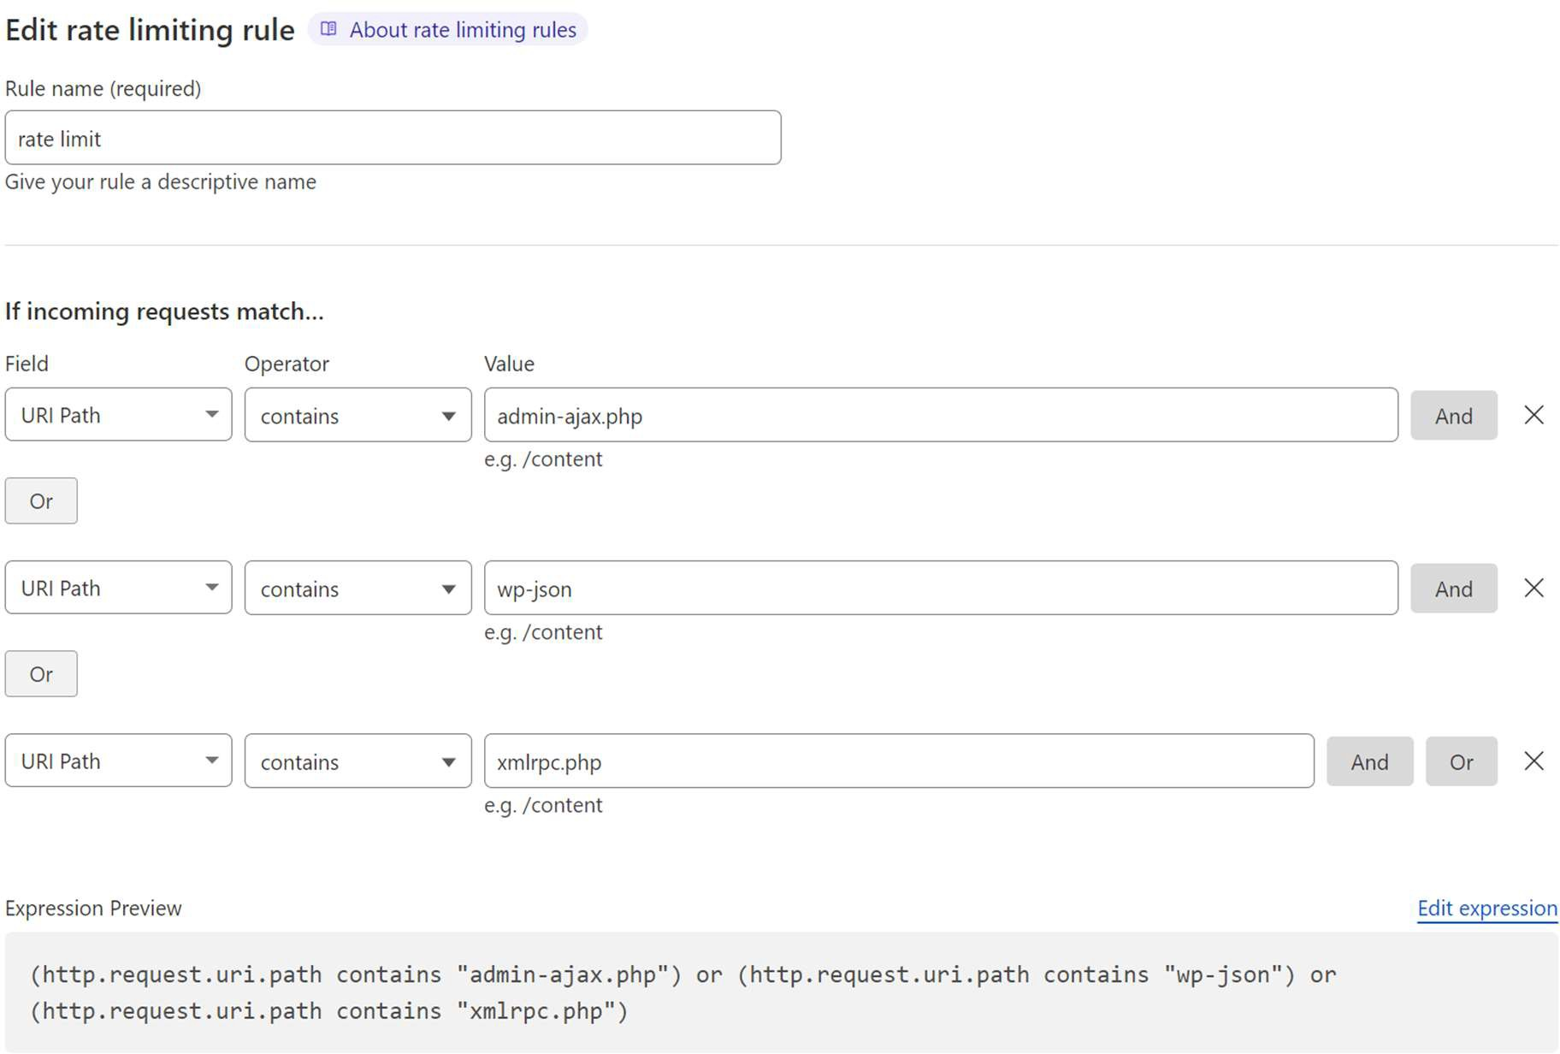

*Figure 68: Rate limiting rule; stops execution of "admin-ajax.php") or "wp-json" or "xmlrpc.php"*

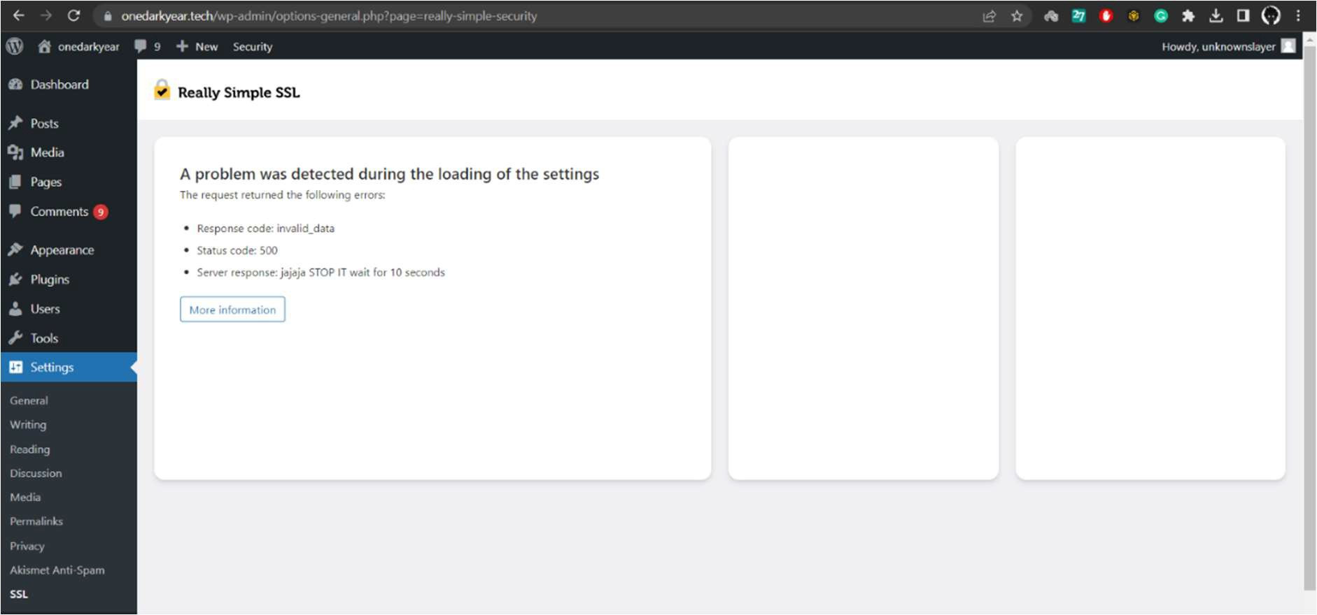

*Figure 69: Result of Rate limiting rule*

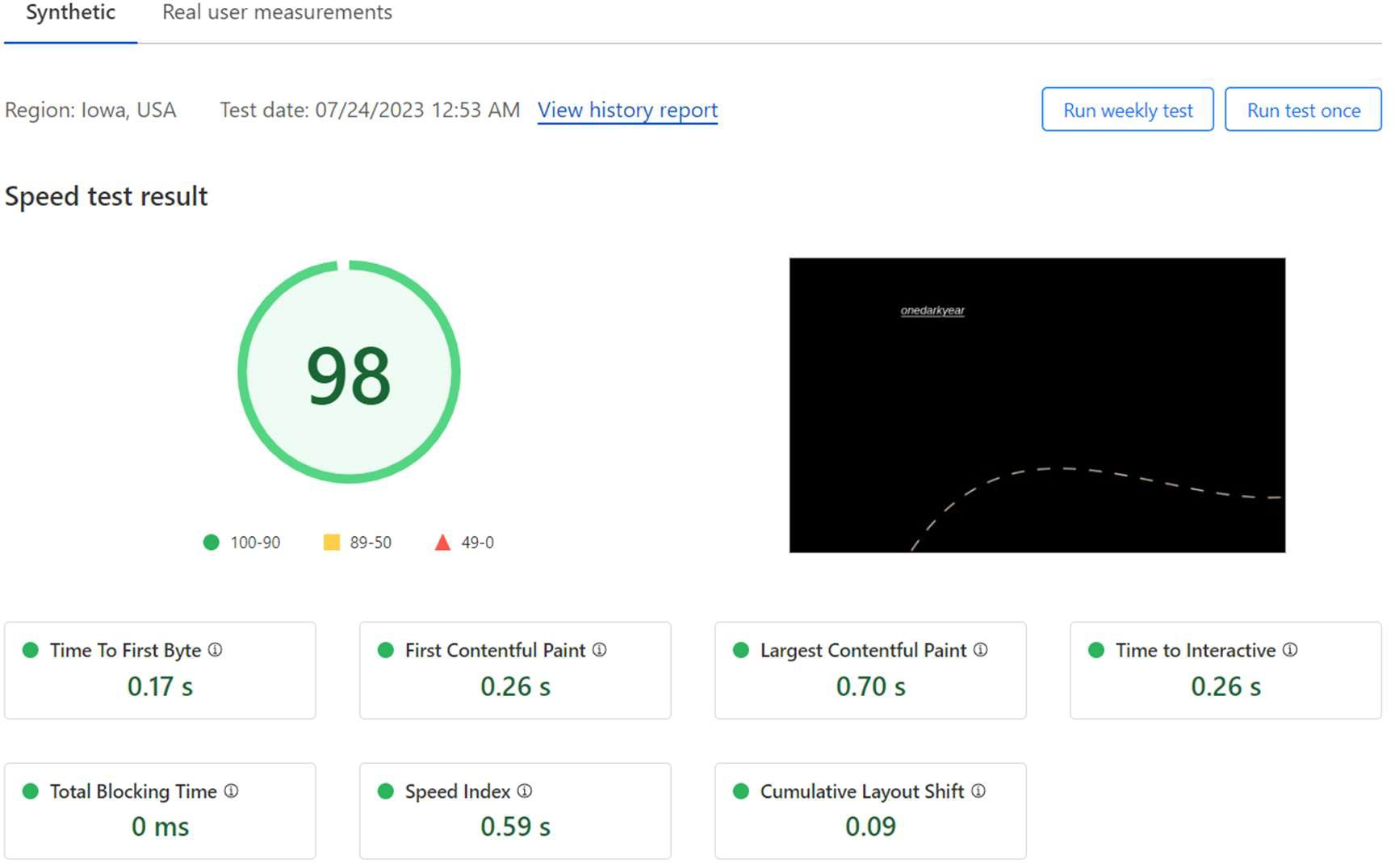

*Figure 70: Simulated speed test*

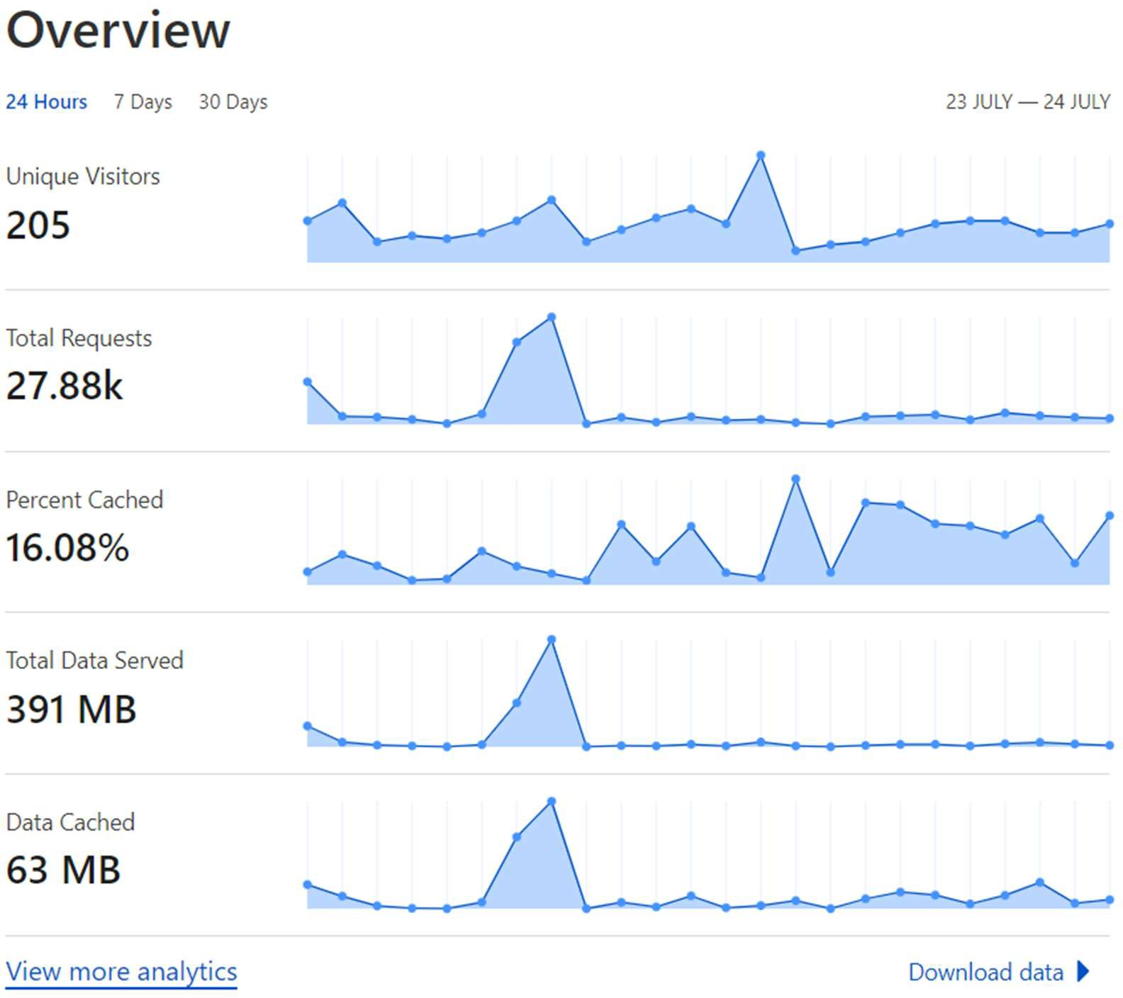

*Figure 71: Overvie of CLoudflare*

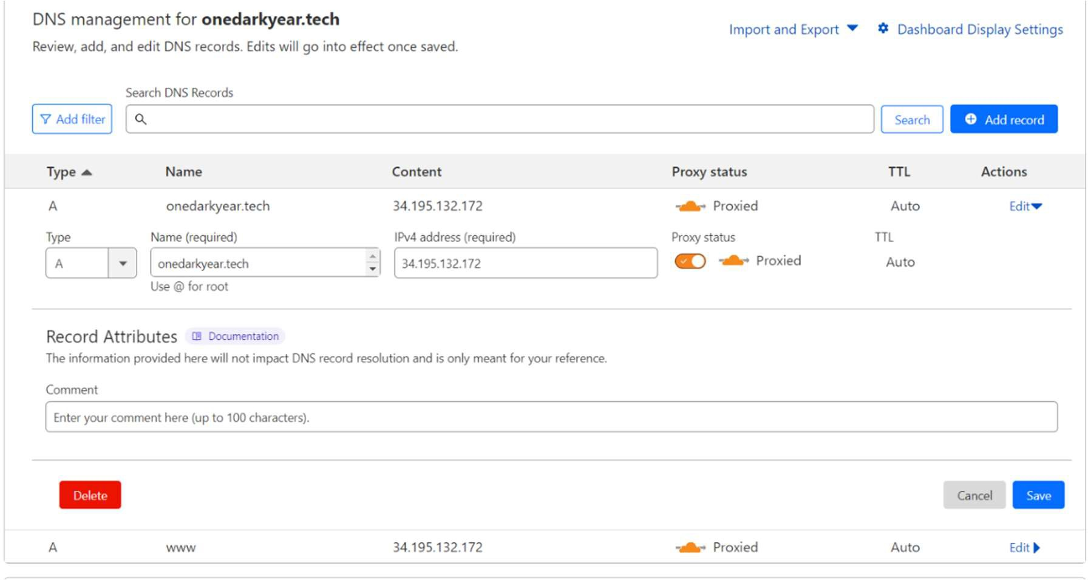

*Figure 72: DNS Management through Cloudflare*

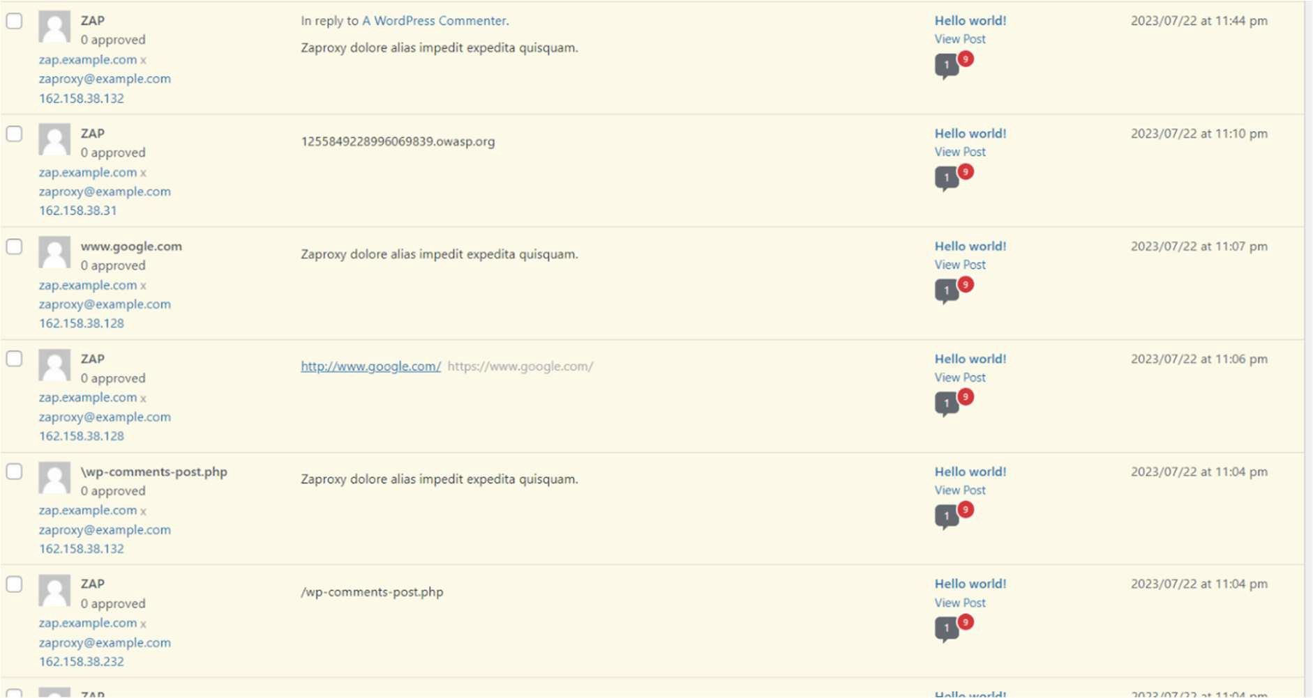

*Figure 73: OWASP ZAP 1*

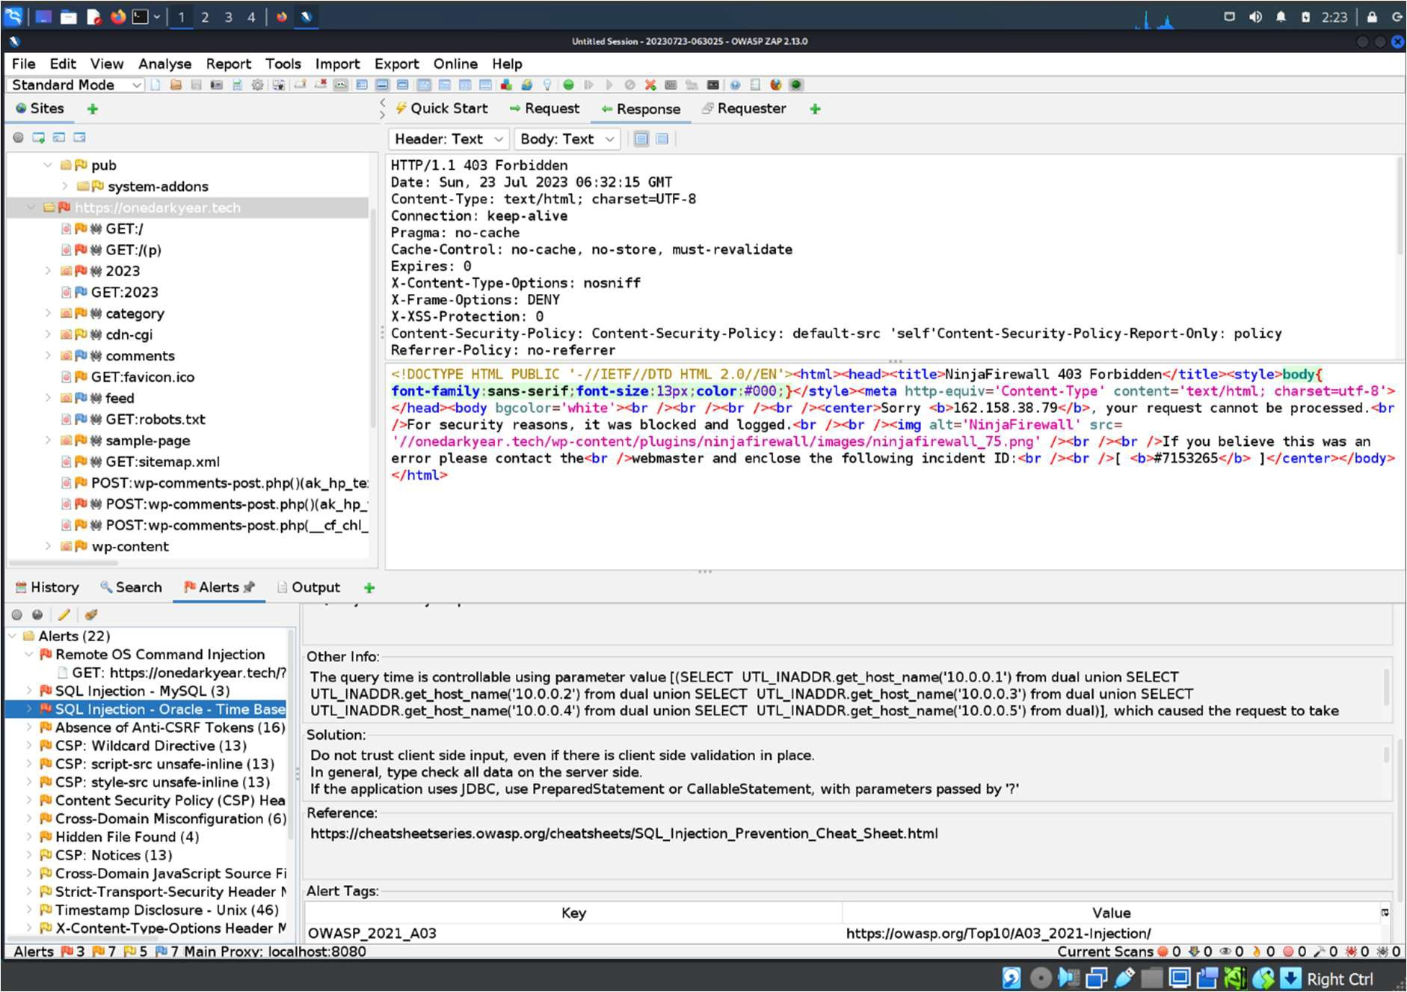

*Figure 74: OWASP ZAP 2*

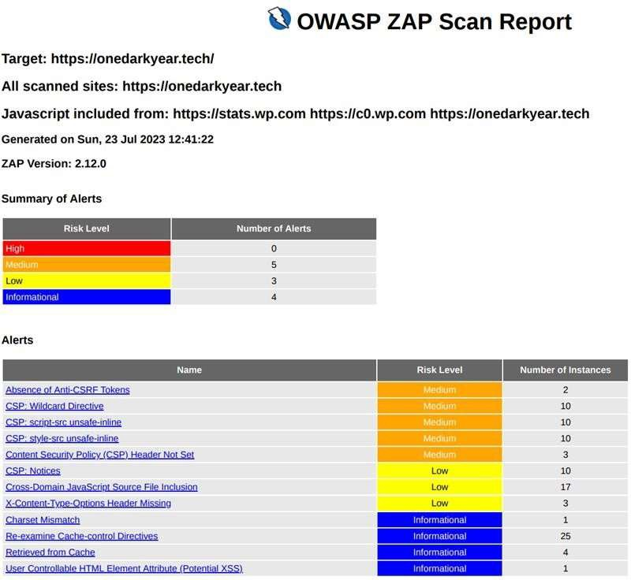

*Figure 75: OWASP ZAP 2 (report)*

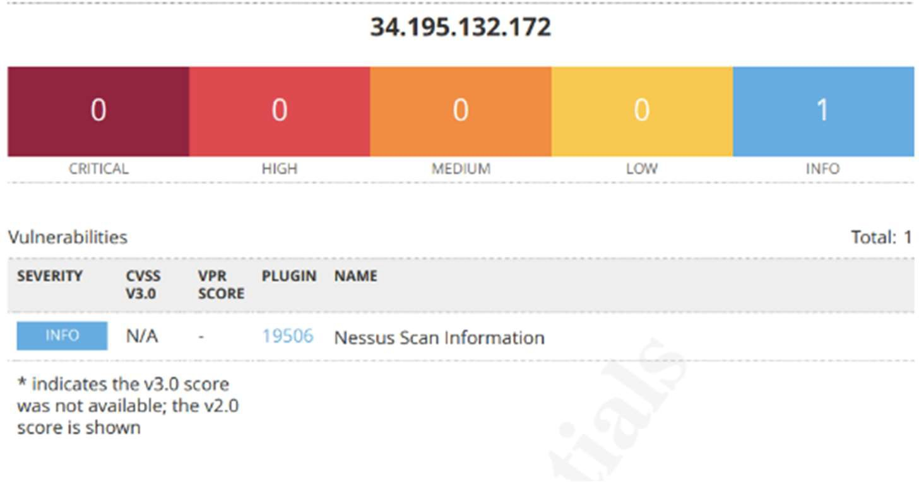

*Figure 76: Nessus host discovery*

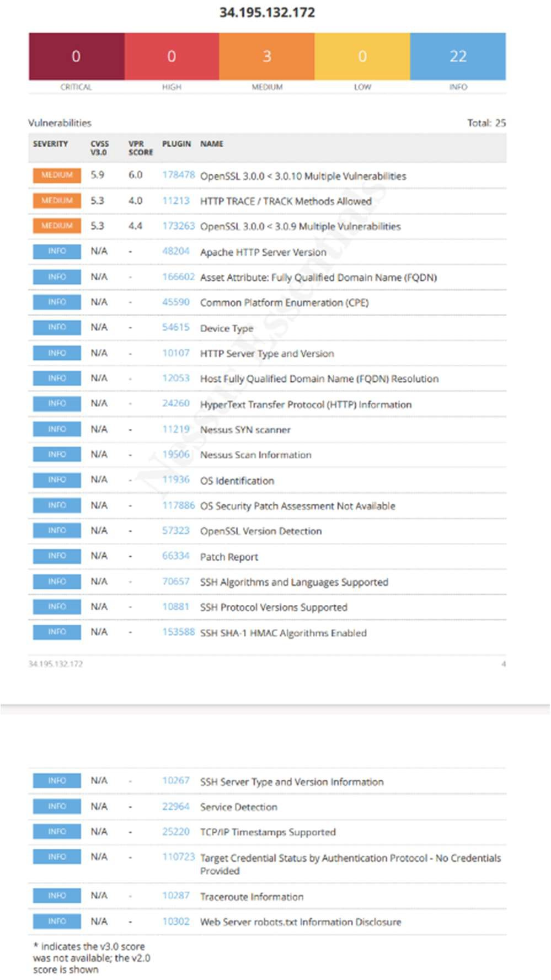

*Figure 77: Nessus Advance scan result*

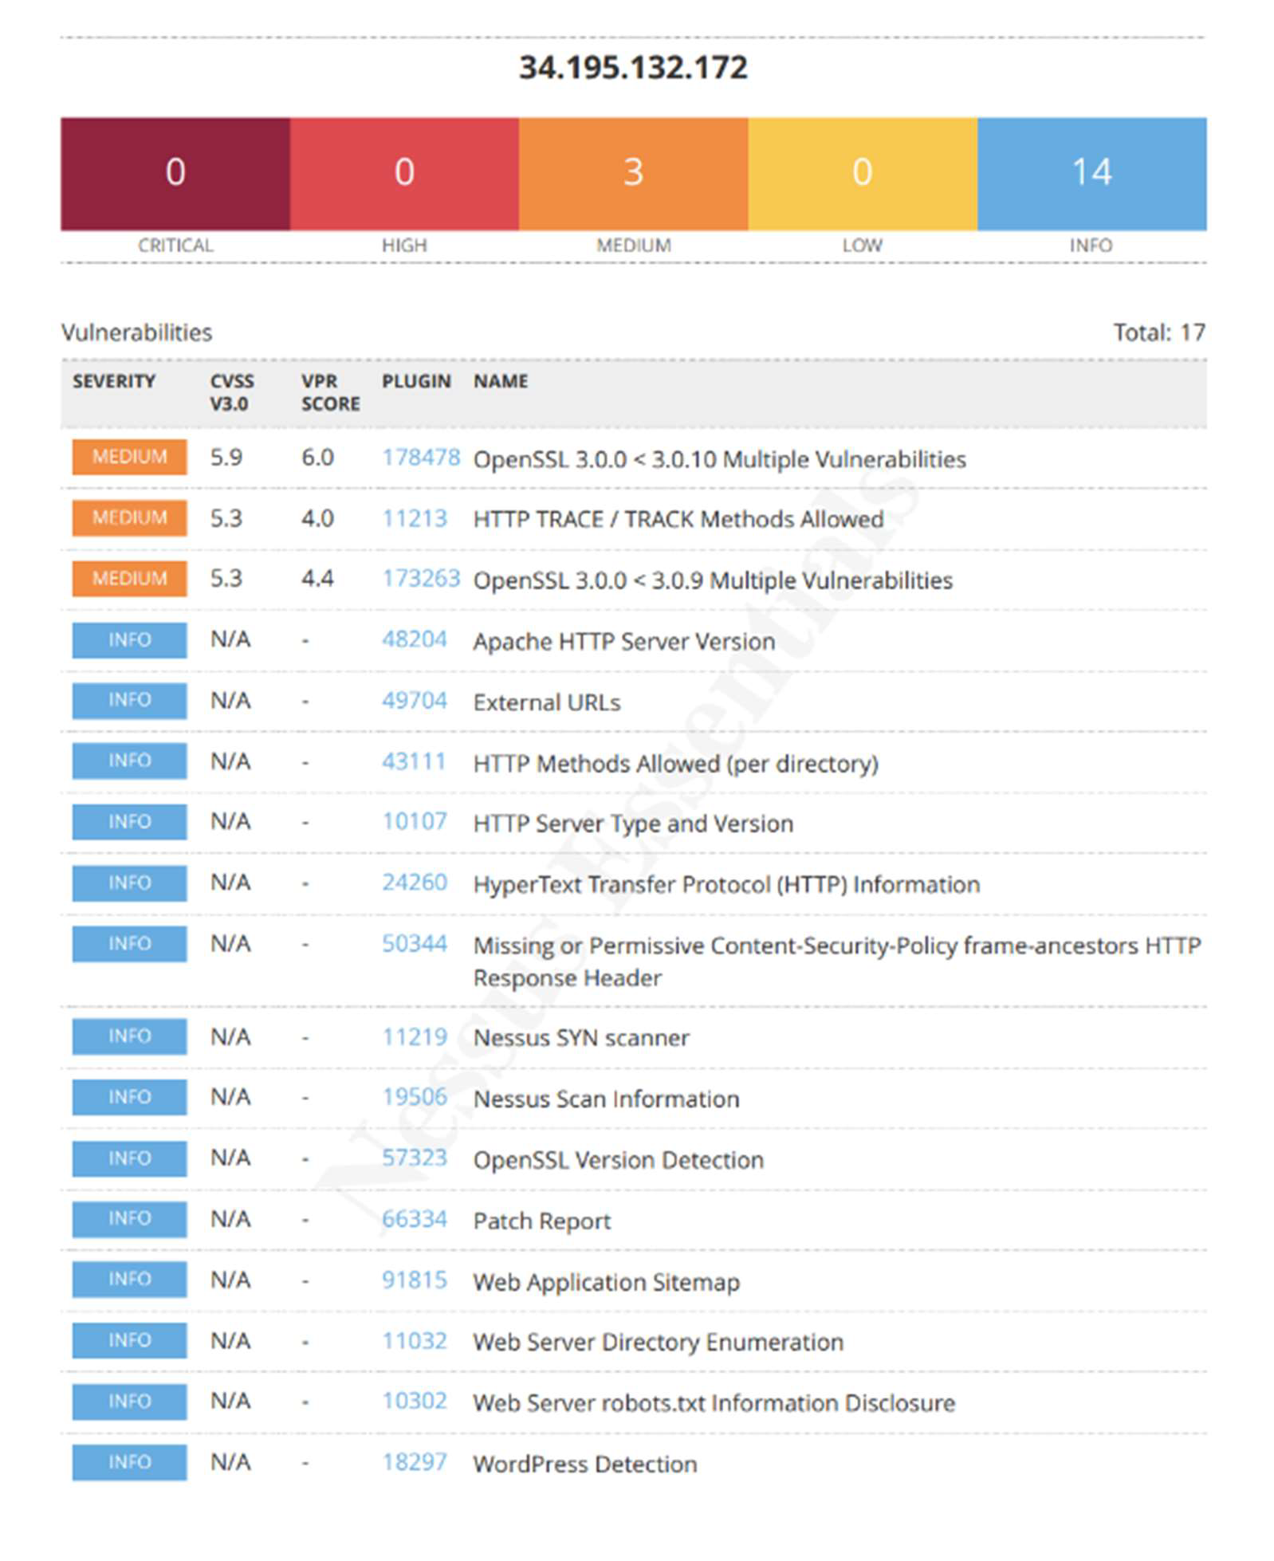

*Figure 78: Nessus application test scan*

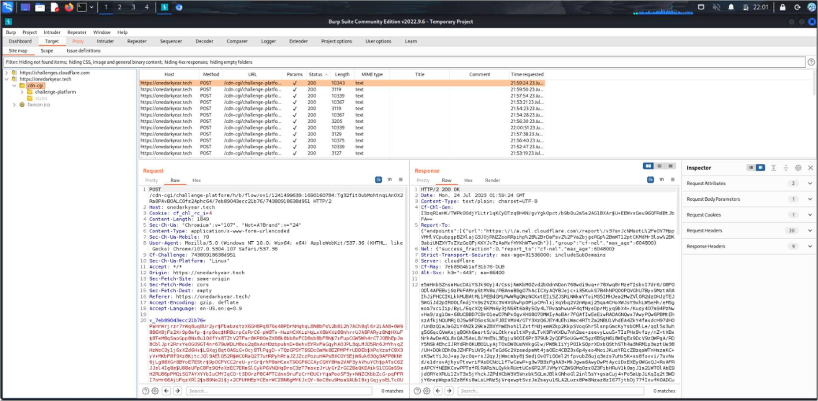

*Figure 79: Birpsuit*

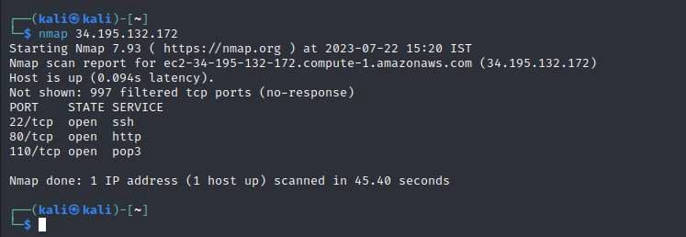

*Figure 80: Nmap*

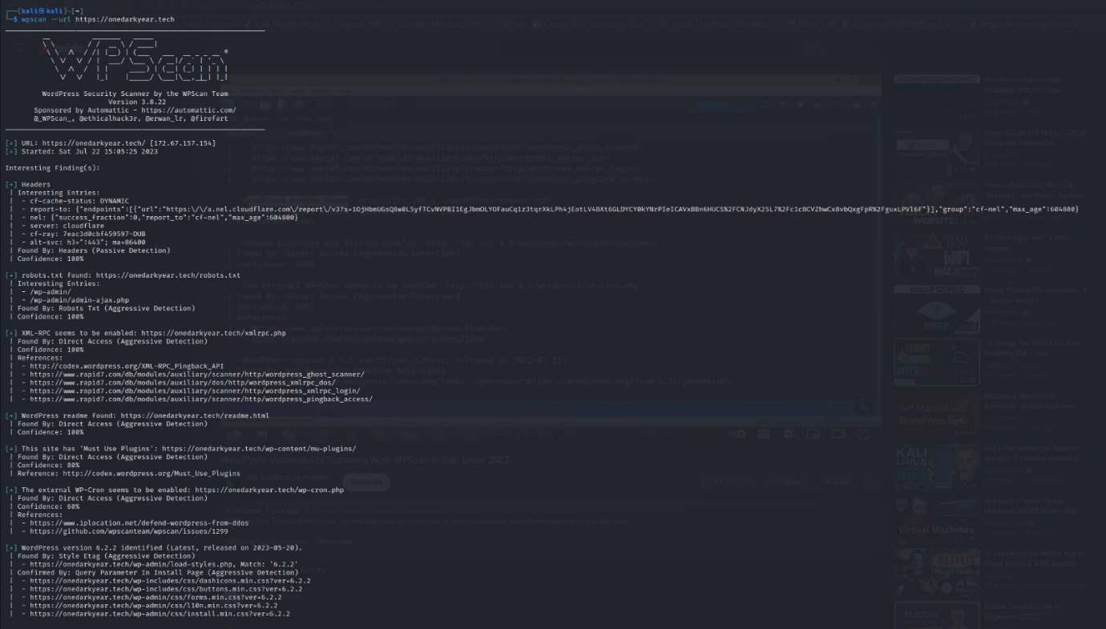

*Figure 81: WP scan before mitigating 1*

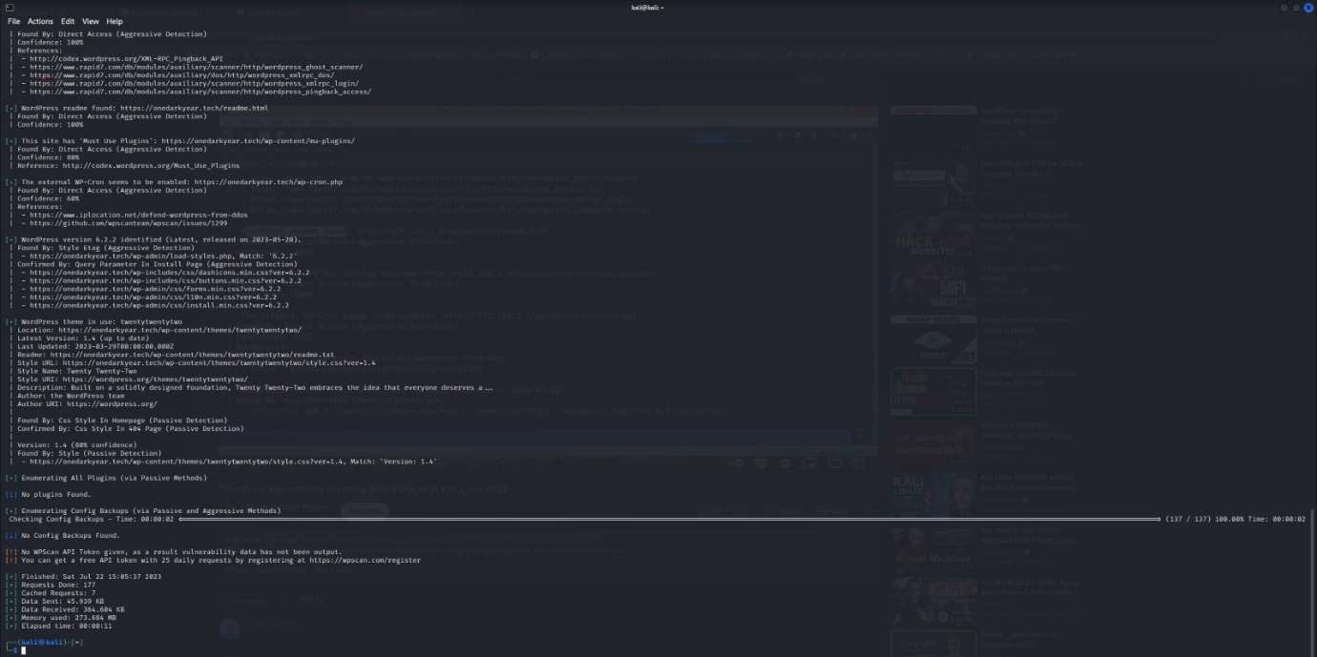

*Figure 82: WP scan before mitigating 2*

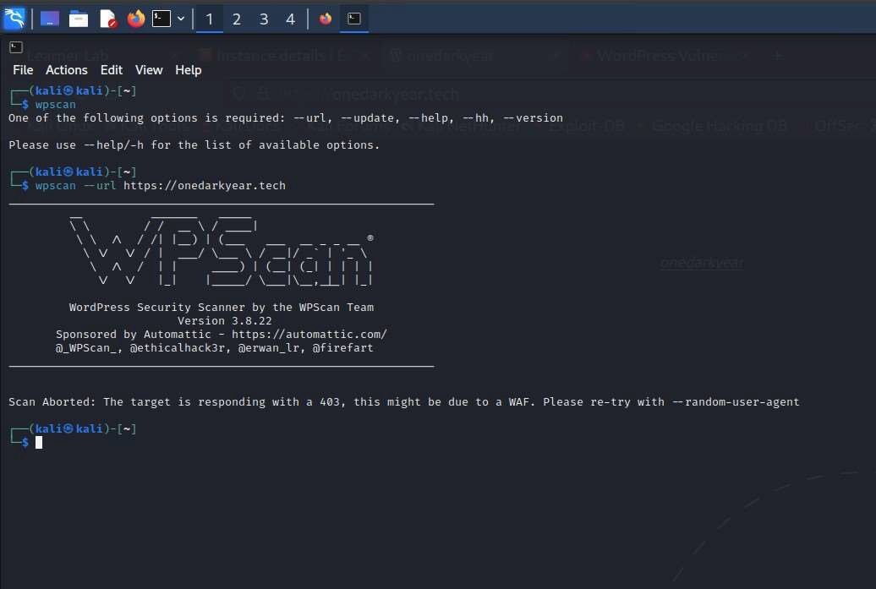

*Figure 83: WP scan after mitigating*

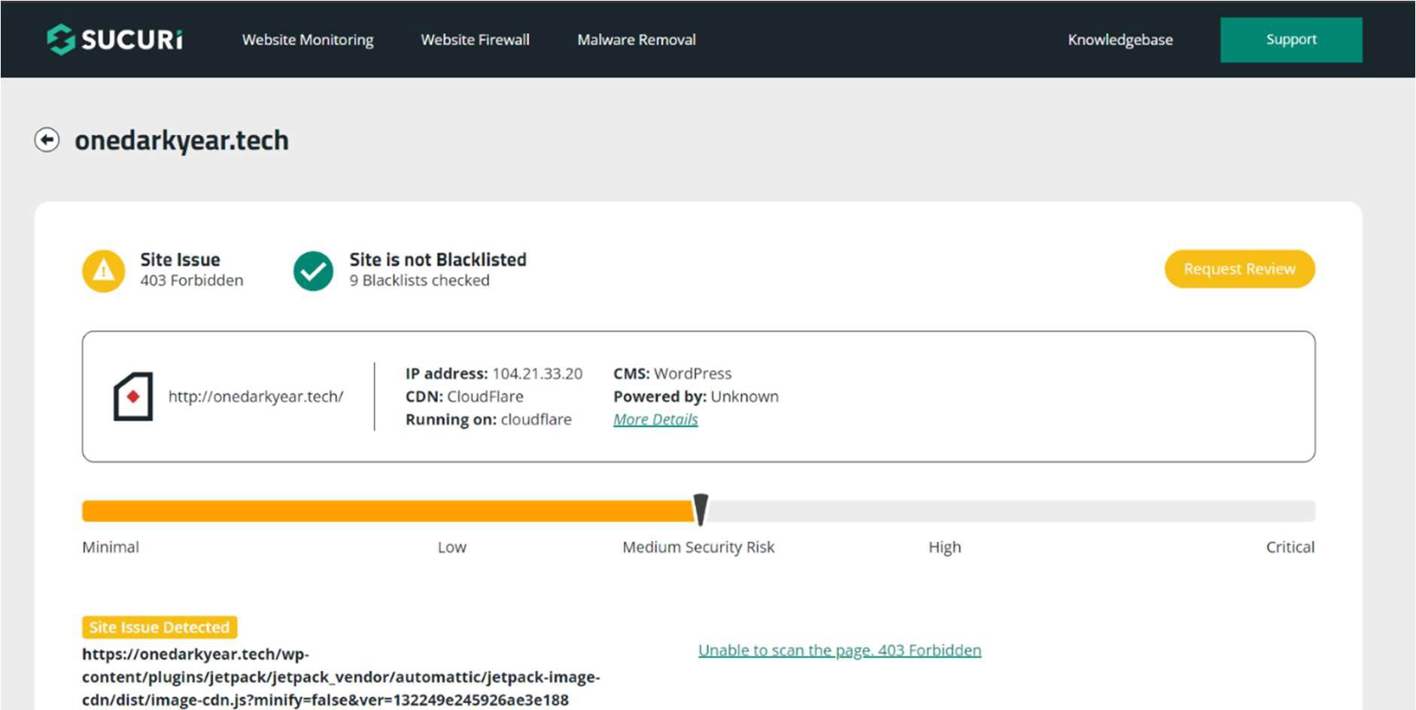

*Figure 84: Sucuri Scan before mitigation*

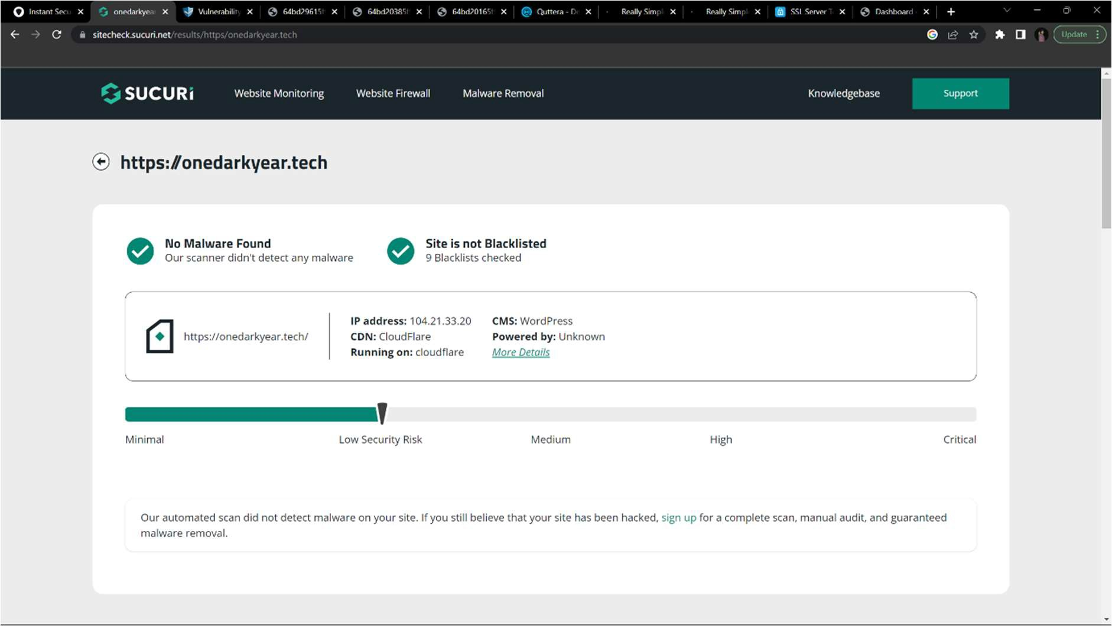

*Figure 85: Sucuri Scan after mitigation*

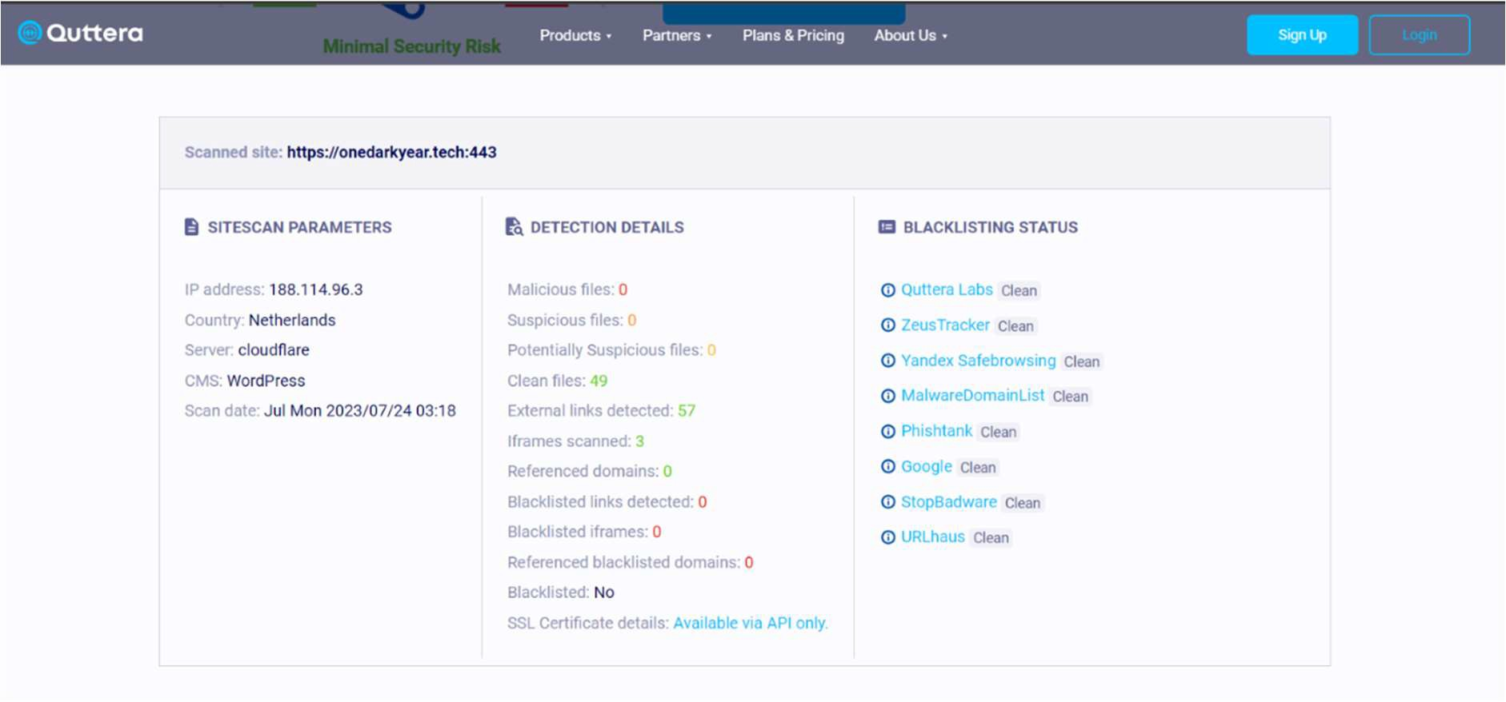

*Figure 86: Quttera scan*

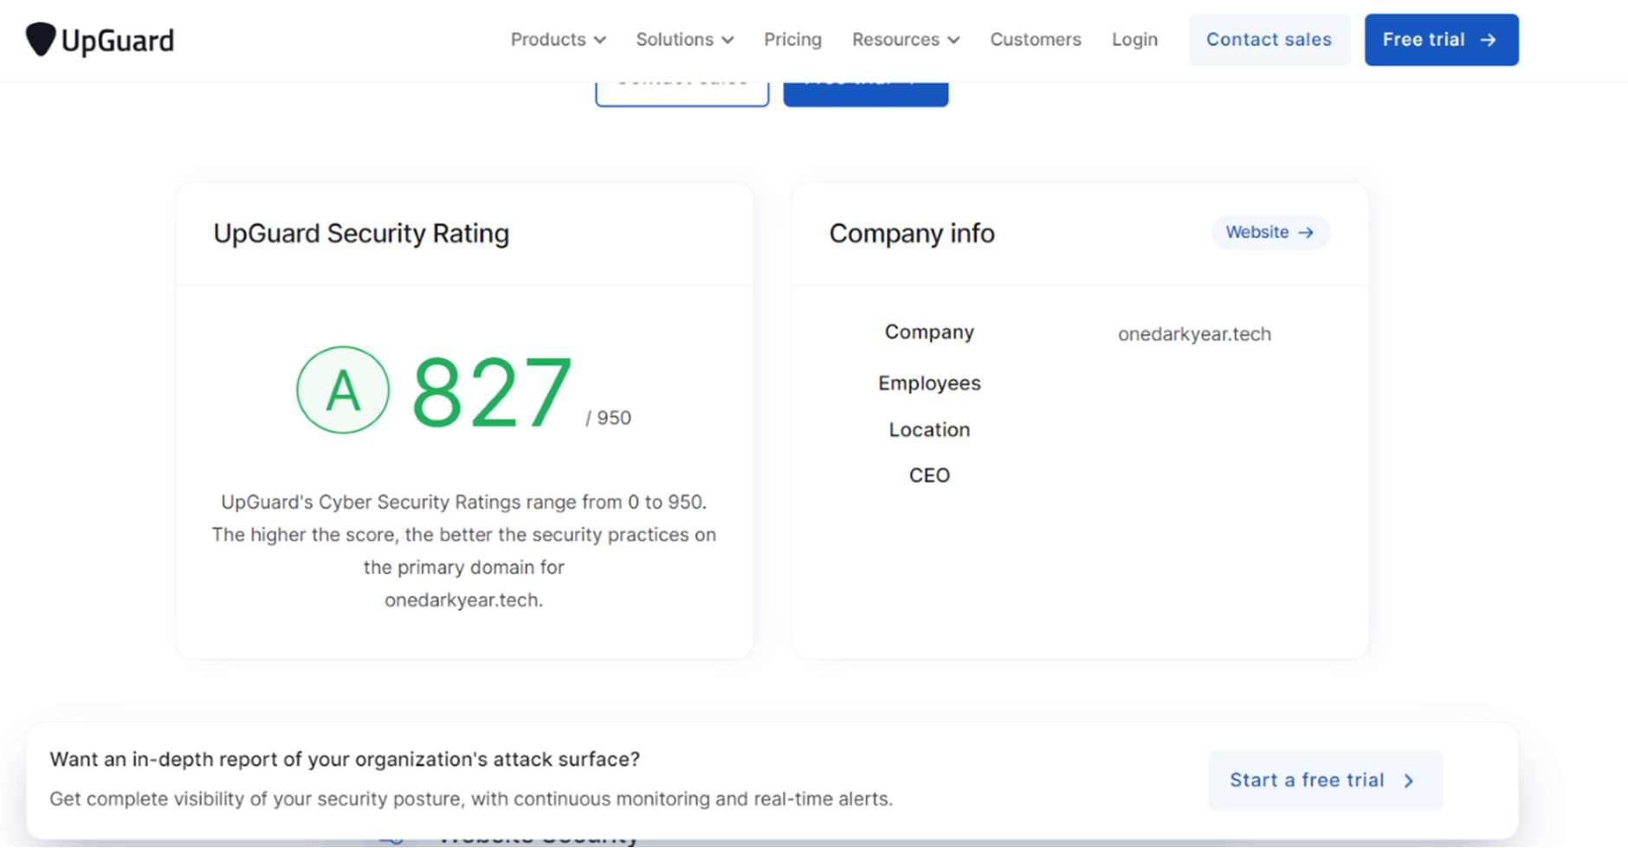

*Figure 87: UpGuard*

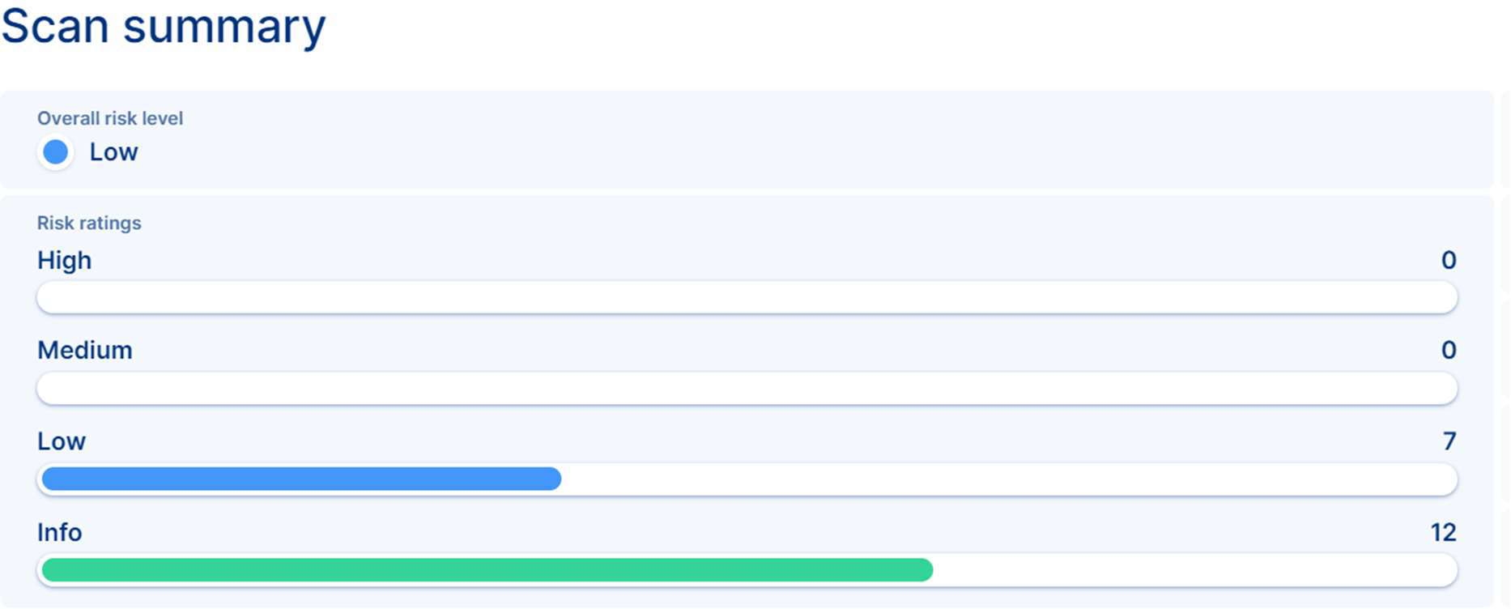

*Figure 88: Pentest-tools 1*



*Figure 89: Pentest-tools 2*

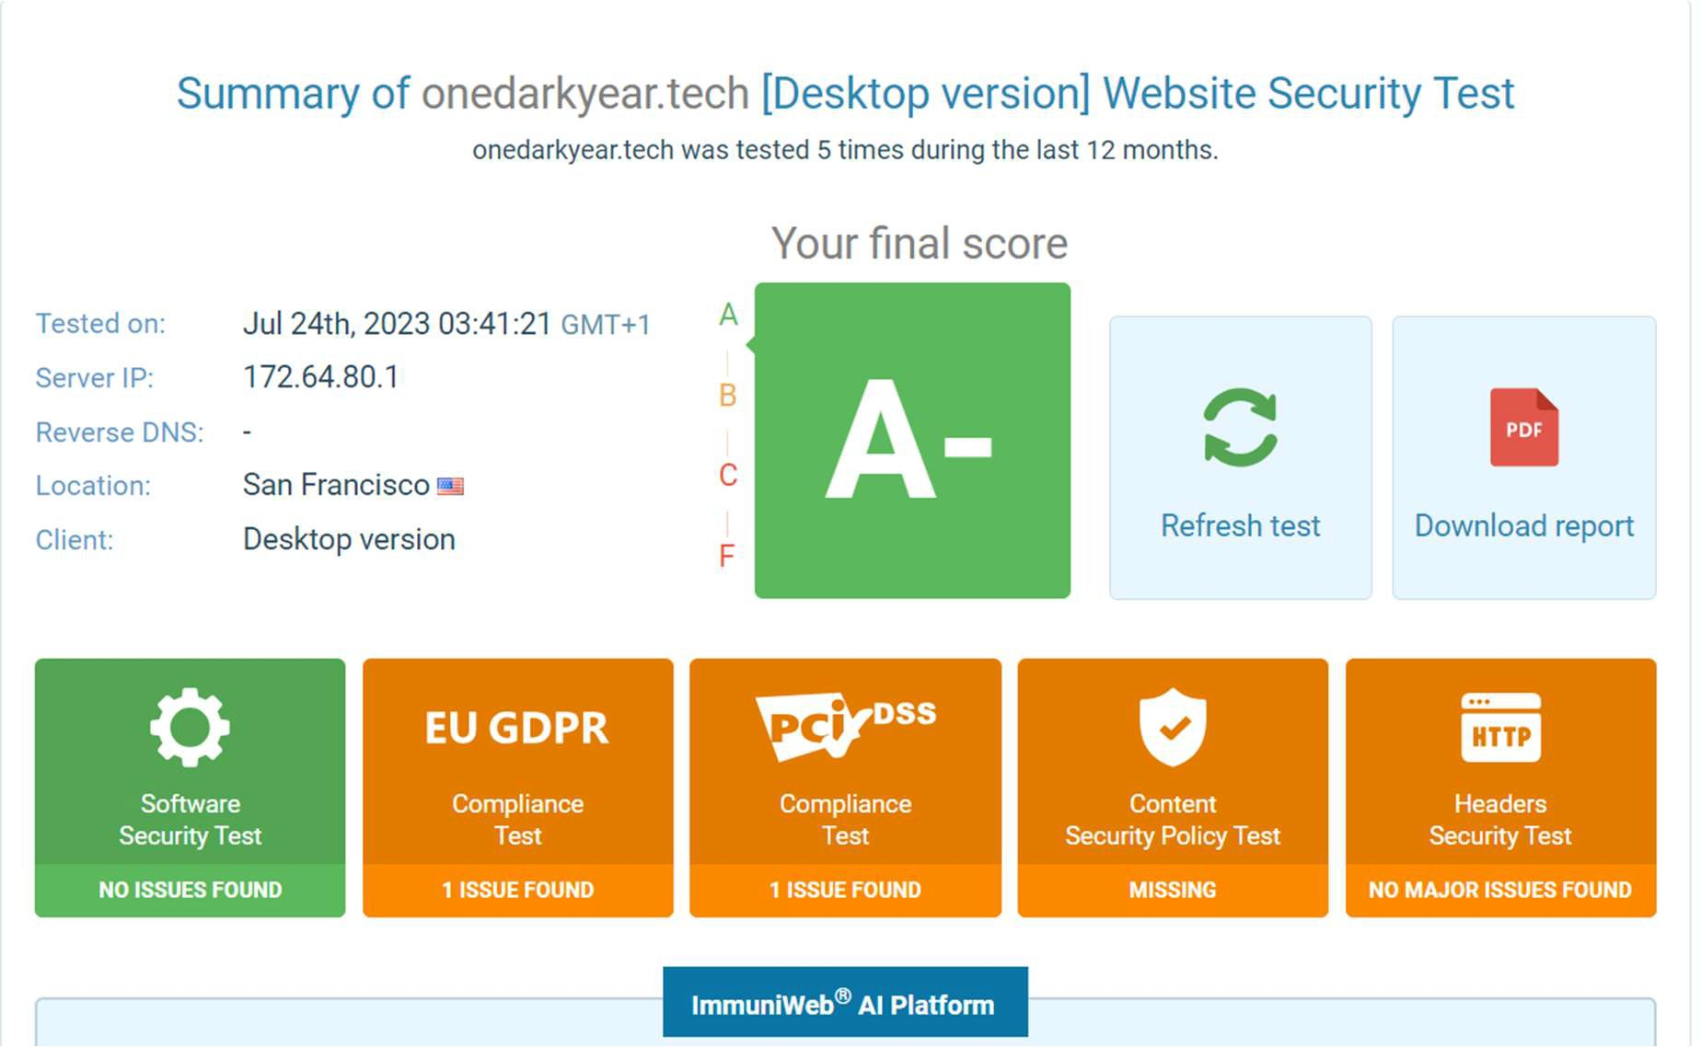

*Figure 90: immuniwep*